Name:_______________________________________________________ Class:_____________

Prime vs. Composite Numbers

Learning Target: I can determine the GCF of 2 or more whole numbers.
Learning Objective: I can distinguish between prime and composite numbers.

(1) Prime Number:
A number larger than 1, that can only be evenly _______________________ by the numbers 1 and itself
Now, using our math vocabulary:

A number ___________________________ than 1, whose only ______________________ are 1 and itself.

Examples:
- 37 is a prime number. The only factors of 37 are: 1, 37

- 11 is a prime number. The only factors of 11 are: 1, 11

- __________________________________________________________________

(2) Composite Number:

A number __________________________ than 1 that can be divided by numbers other than

_____________________ and _____________________
Now, using our math vocabulary:

A number _____________________ than 1 who has more than 1 ____________________
Examples:
- 63 is a composite number. The factors of 63 are: 1, 3, 7, 9, 21, 63

- 40 is a composite number. The factors of 40 are: 1, 2, 5, 8, 20, 40

- __________________________________________________________________
The Prime Numbers up to 100 are:
2 | 3 | 5 | 7 | 11 | 13 | 17 | 19 | 23 | 29 | 31 | 37 | 41 | 43 | 47 | 53 | 59 | 61 | 67 | 71 | 73 | 79 | 83 | 89 | 97
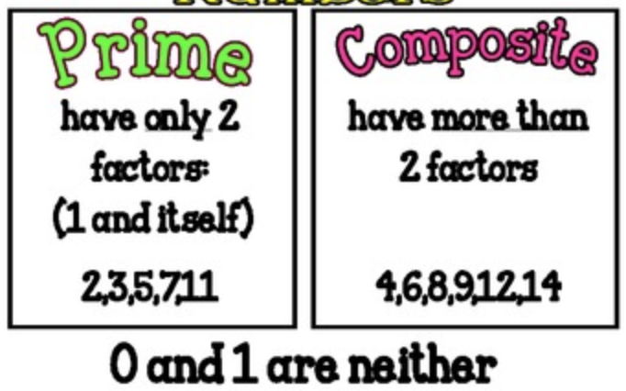
Name:_______________________________________________________ Class:_____________

Prime vs. Composite Numbers

Learning Target: I can determine the GCF of 2 or more whole numbers.
Learning Objective: I can distinguish between prime and composite numbers.

(1) Prime Number:
A number larger than 1, that can only be evenly divided by the numbers 1 and itself
Now, using our math vocabulary:

A number greater than 1, whose only factors are 1 and itself.

Examples:
- 37 is a prime number. The only factors of 37 are: 1, 37

- 11 is a prime number. The only factors of 11 are: 1, 11

- __________________________________________________________________

(2) Composite Number:

A number larger than 1 that can be divided by numbers other than

1 and itself
Now, using our math vocabulary:

A number greater than 1 who has more than 1 factor pair
Examples:
- 63 is a composite number. The factors of 63 are: 1, 3, 7, 9, 21, 63

- 40 is a composite number. The factors of 40 are: 1, 2, 5, 8, 20, 40

- __________________________________________________________________
The Prime Numbers up to 100 are:
2 | 3 | 5 | 7 | 11 | 13 | 17 | 19 | 23 | 29 | 31 | 37 | 41 | 43 | 47 | 53 | 59 | 61 | 67 | 71 | 73 | 79 | 83 | 89 | 97

