Name:____________________________________________________ Class:___________ Date:__________
Learning Target: I can multiply decimals.
Do Now: Select the best answer for the question below. Explain your answer in complete sentences.
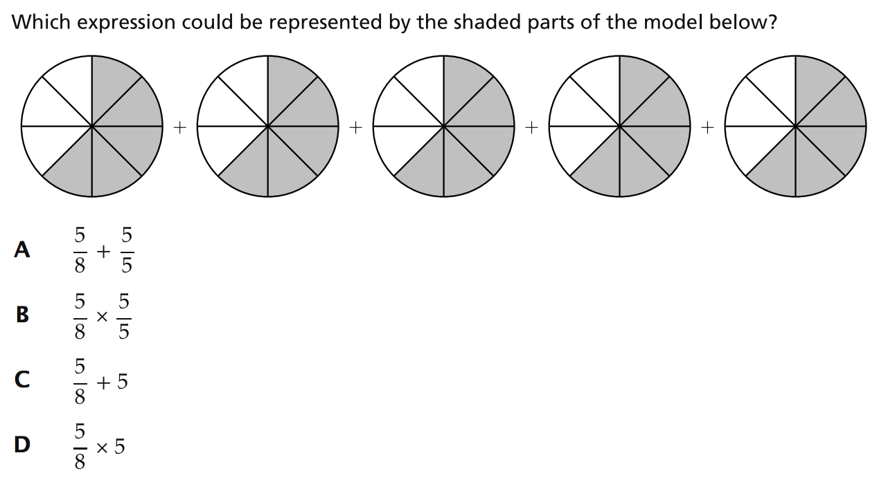
Explanation:________________________________________________________________________________

__________________________________________________________________________________________

__________________________________________________________________________________________

Name:____________________________________________________ Class:___________ Date:__________
Learning Target: I can multiply decimals.
Do Now: Select the best answer for the question below. Explain your answer in complete sentences.
Explanation:________________________________________________________________________________

__________________________________________________________________________________________

__________________________________________________________________________________________
Name:____________________________________________________ Class:___________ Date:__________
Learning Target: I can multiply decimals.
While watching the video…
(1) What is a common mistake made when multiplying decimals?

(2) Shade in the hundredths block to show the solution for 0.3 x 0.5:
Prove it!:
0.3
x 0.5

(3) Shade in the hundredths block to show the solution for 0.4 x 0.5:

Prove it!:
0.4
x 0.5

Name:____________________________________________________ Class:___________ Date:__________
Learning Target: I can multiply decimals.
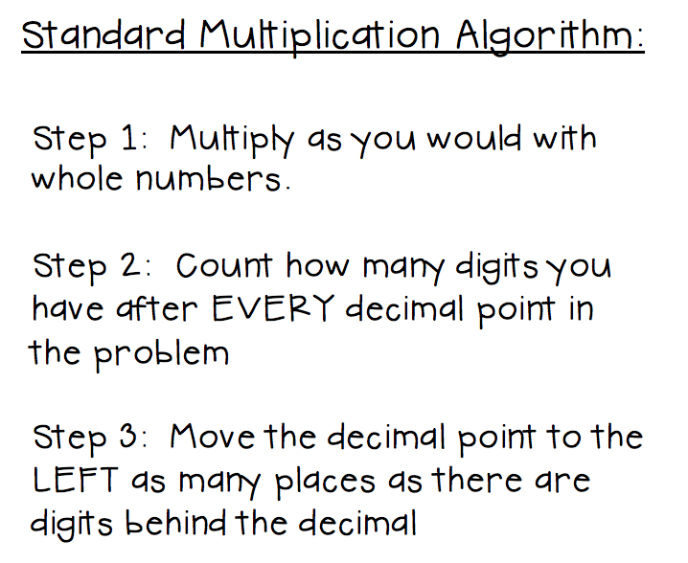
Multiplying a decimal by a whole number:
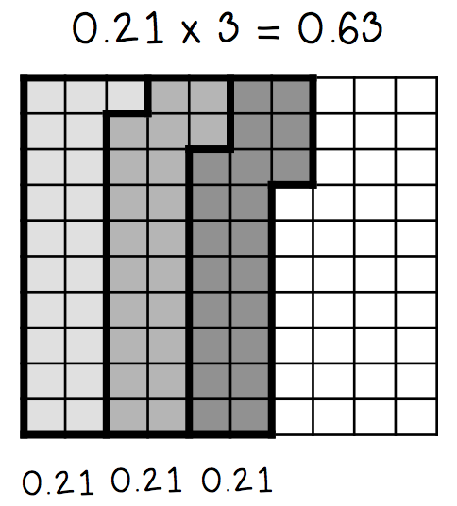

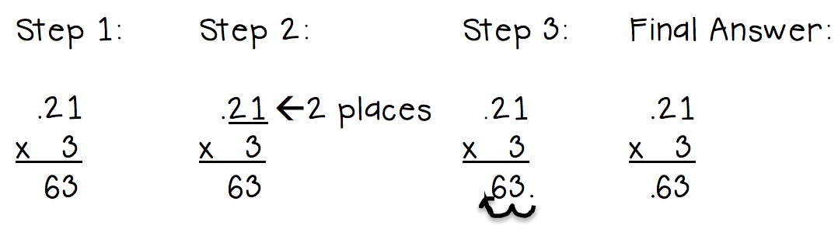
Multiplying a decimal by a decimal:
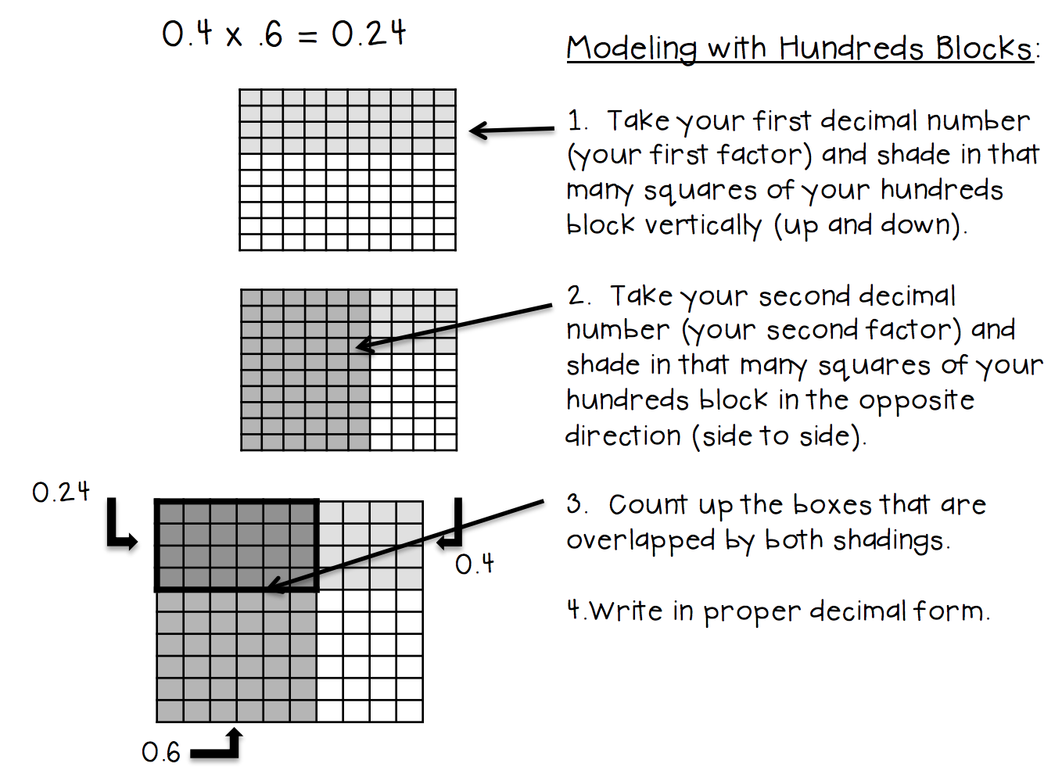
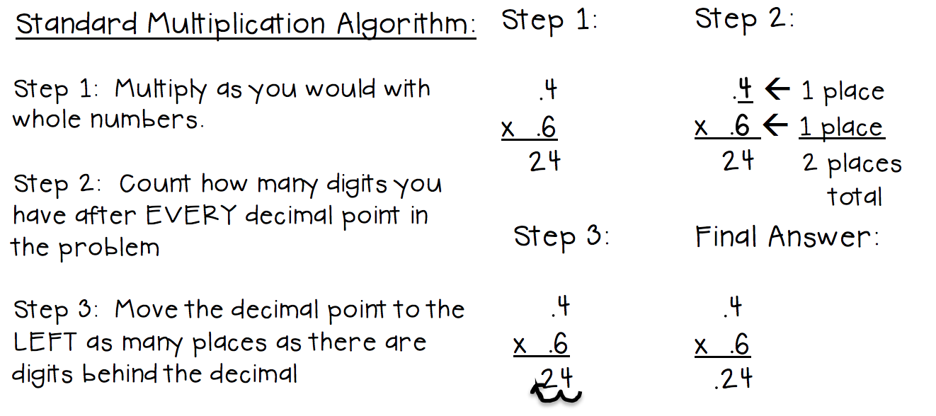
Other examples:
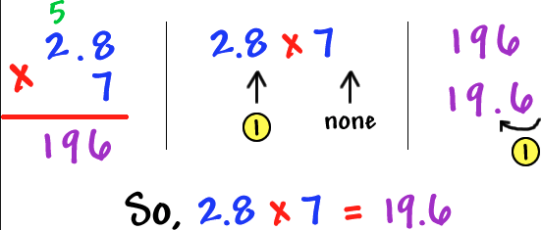
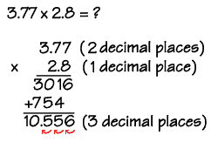

You try…
(1) 0.12 x 5 = | (2) 0.3 x 0.25 = | (3) 0.2 x 1.3 =

Name:____________________________________________________ Class:___________ Date:__________
Learning Target: I can multiply decimals.
Multiplying a decimal by a whole number:
Paso 1: multiplica como lo harías con números enteros.
Paso 2: cuente cuántos dígitos tiene después de cada punto decimal en el problema.
Paso 3: mueva el punto decimal a la izquierda tantos lugares como hay dígitos detrás del decimal.

Multiplying a decimal by a decimal:
Paso 1: multiplica como lo harías con números enteros.
Paso 2: cuente cuántos dígitos tiene después de cada punto decimal en el problema.
Paso 3: mueva el punto decimal a la izquierda tantos lugares como hay dígitos detrás del decimal.

Other examples:

You try…
(1) 0.12 x 5 = | (2) 0.3 x 0.25 = | (3) 0.2 x 1.3 =

