Name: ___________________________________________________ Class: _________ Date: _________

Learning Target: I can compare and order integers.

Ordering Integers
Integers are positive and negative whole numbers, including zero.
Number lines can be used to represent integers.

The arrows indicate that the number line goes on indefinitely in both directions.

- Positive Integers – are all the whole numbers ______________________________ than zero. These numbers are to the ______________________ of zero on the number line. *A number with no sign is considered positive.
- Negative Integers – are all the numbers _____________________ than zero. These numbers are to the _________________________________ of zero on the number line.

Integers on the Number Line
The farther ___________________________ on the number line, the bigger the number. The farther left a number is on the number line, the _______________________________ the number.

Smaller Greater
If you wanted to compare the integers -4 and 5, you would draw and label a number line and put a “point” at the integer location.
Because 5 is farther to the right than -4, 5 is greater than -4. So, we can say 5 > -4.

Directions: Order the integers from least to greatest.
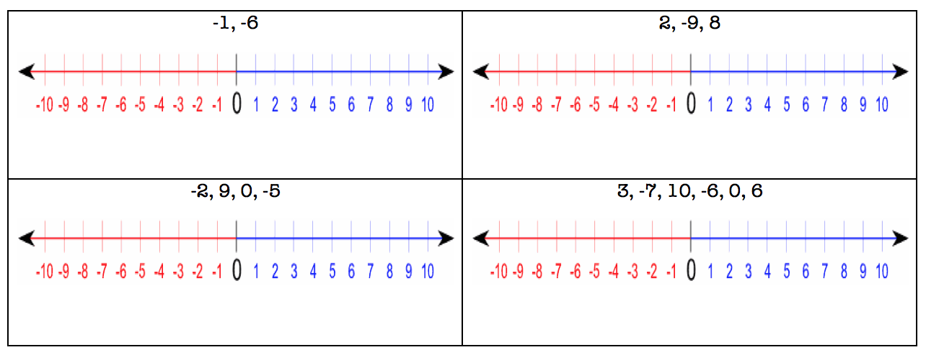

Name: ___________________________________________________ Class: _________ Date: ___________

Learning Target: I can compare and order integers.

Ordering Integers
Directions: Order each set of integers from greatest to least and least to greatest.
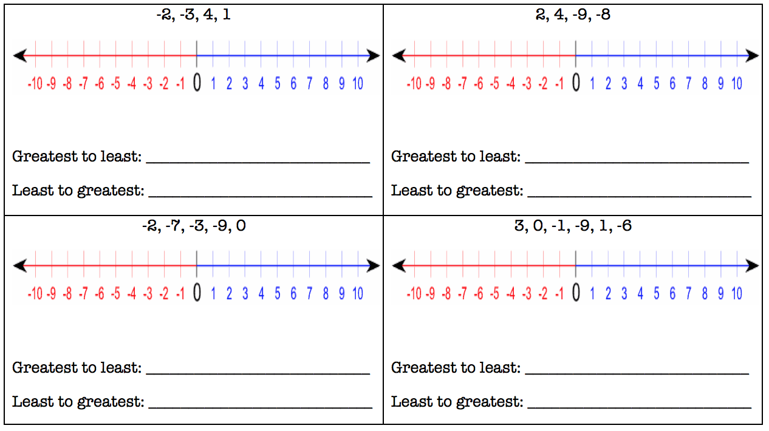

Name: ___________________________________________________ Class: _________ Date: ____________

Learning Target: I can compare and order integers.

Ordering Integers
Directions: Order each set of integers from greatest to least and least to greatest.

Answers

Learning Target: I can compare and order integers.

Ordering Integers
Integers are positive and negative whole numbers, including zero.
Number lines can be used to represent integers.

The arrows indicate that the number line goes on indefinitely in both directions.

- Positive Integers – are all the whole numbers greater than zero. These numbers are to the left of zero on the number line. *A number with no sign is considered positive.
- Negative Integers – are all the numbers less than zero. These numbers are to the right of zero on the number line.

Integers on the Number Line
The farther right on the number line, the bigger the number. The farther left a number is on the number line, the smaller the number.

Smaller Greater
If you wanted to compare the integers -4 and 5, you would draw and label a number line and put a “point” at the integer location.
Because 5 is farther to the right than -4, 5 is greater than -4. So, we can say 5 > -4.

Directions: Order the integers from least to greatest.

