Name:____________________________________________________ Class:__________ Date:___________
Do Now
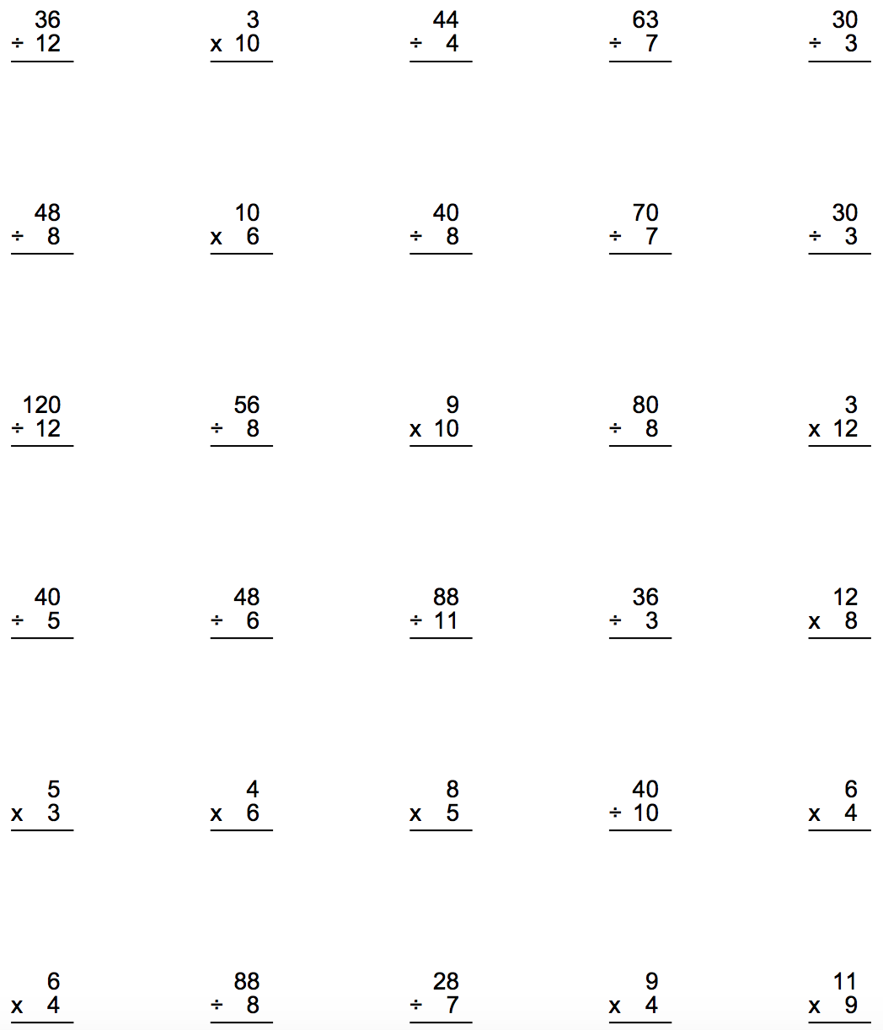
Name:________________________________________________ Class:___________ Date:_____________
Extra Practice
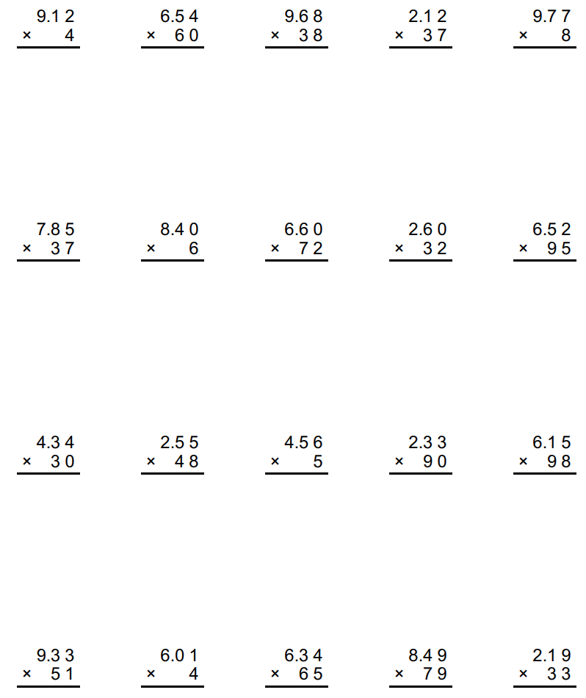

Name:________________________________________________________ Class:_________ Date:_________

1.2 x 0.5 | Justin earned $0.50 per mile for every mile walked in a fundraiser. He walked 1.2 miles. How much money did he earn altogether?
2.4 x 0.7 | The width of a park is 0.5 mile and the length of a park is 0.6 mile. What is the area of the park?
0.5 x 0.6 | A pound of oranges costs $0.70 per pound. You purchased 2.4 pounds. How much money did you spend on the oranges?
7 x 0.24 | Gianna saved 1.2 oz. of chocolate from the holidays. She gave away half of her chocolate. How much chocolate did she give away?
1.2 x 0.5 | You added 6 cents into your piggy bank every day for 5 days. How much money did you add into your bank in total?
5 x 0.06 | Jayden has beads that are 0.24 cm. long. If he uses 7 to string together to make a bracelet, how long is the bracelet?
Ms. Maljevic has 5 bags with candy in them. Each bag has 0.6 lbs. of candy. How much candy is in all of the bags combined? | Ms. Madden walked 0.5 mile each day for 12 days. How far did she walk in total after the 12th day?

Name:____________________________________________________________________ Date:_____________ Class:_____________
CW: Multiplying Decimals Matching Activity
Word Problem | Equation | Solution

Word Problem | Equation | Solution

Readiness  -arrived to class on time  -worked through the do now for the entire time allotted  /10 | Positive Contribution  -actively worked through the class activity  -remained on task  /30 | Understanding  -correctly matched each situation to the accurate number sentence  -accurately solved each equation  /60
Grade:

