Learning Targets:
I can identify the greatest common factor for two or more numbers
I can identify the least common multiple for two or more numbers.
I can recognize situations that require the greatest common factor of or the least common multiple of two or more whole numbers.

Mastery Scoring Sheet

Overall score: __________/12 ____________%

Learning Target 1: I can identify the greatest common factor of two or more whole numbers.
Questions: 1, 4, 7

Score: ___________/ 3 Circle: Met Did not meet

Learning Target 2: I can identify the least common multiple of two or more whole numbers.
Questions: 2, 5, 9

Score: ___________/ 3 Circle: Met Did not meet

Learning Target 3: I can recognize situations that require the greatest common factor of or the least common multiple of two or more whole numbers.
Questions: 3, 6, 8

Score: ___________/ 3 Circle: Met Did not meet

Short response question: (3 pt. rubric)

Score: ___________/ 3
Correct = 3 pts. Partially Correct = 1 OR 2 pts. Incorrect = 0 pts.

Notes:
Learning Targets: I can identify the greatest common factor for two or more numbers.
I can identify the least common multiple for two or more numbers.
I can recognize situations that require the greatest common factor of or the least common multiple of two or more whole numbers.
_________ 1. What is the greatest common factor of 10 and 6?
A. 6 B. 2 C. 10 D. 20

_________ 2. What is the least common multiple of 5 and 6?
A. 6 B. 15 C. 20 D. 30

_________ 3. Molly has 16 oranges and 12 apples. She wants to create fruit baskets with an equal number of pieces of fruit in each basket. If she is going to create the largest possible number of baskets, how many pieces of fruit can she put in each basket?

A. 4 oranges & 3 apples B. 1 orange & 2 apples C. 16 oranges & 12 apples D. 6 oranges & 3 apples

_________ 4. What is the greatest common factor of 15 and 25?
A. 5 B. 15 C. 3 D. 30

_________ 5. What is the least common multiple of 6 and 8?
A. 40 B. 24 C. 16 D. 48

_________ 6. Bus A and Bus B are all at the Main Street bus stop at 7:00AM. Bus A comes back to that stop every 8 minutes. Bus B comes back to that stop every 10 minutes. How many minutes will pass before all both buses will be there again?
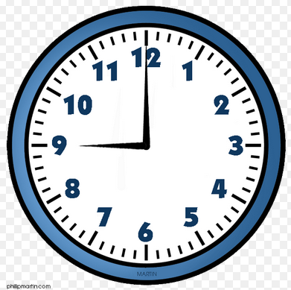
A. 25 minutes B. 60 minutes C. 30 minutes D. 40 minutes

_________ 7. What is the GCF of 8 and 20?
A. 160 B. 4 C. 8 D. 2

_________ 8. Chris has 20 lollipops and 30 tootsie rolls. He is making goody bags for a birthday party. He wants to put an equal number of lollipops and tootsie rolls in each bag. What is the largest number of bags he can create?
A. 10 B. 5 C. 25 D. 50

_________ 9. What is the LCM of 12 & 6?
A. 12 B. 6 C. 3 D. 2

10. Mr. Warnock is shopping for hot dogs and hot dog buns. The hot dogs come in packs of 10, and the hot dog buns come in packs of 8. Mr. Warnock needs an equal number of hot dogs and hot dog buns.
Part A: What is the smallest number of each pack that Mr. Warnock can purchase in order to have an equal number of each item?
Show your work:

Answer:______________________________________________________________________________________
Part B:
Explain your answer in complete sentences using your math vocabulary: __________________________________

____________________________________________________________________________________________

____________________________________________________________________________________________

____________________________________________________________________________________________

