Dear Parents and Guardians,

Welcome to 6th Grade Unit 1: The Number System
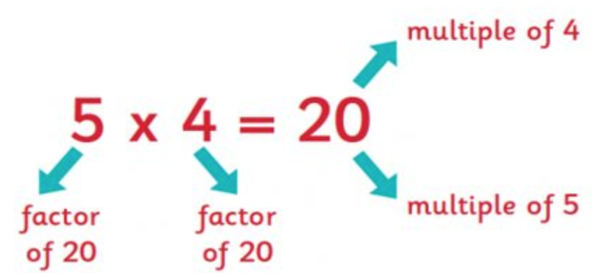
Today, in class, your child received their Unit 1: The Number System outline. The outline is also available online. It includes all of the learning targets taught in this unit, along with an example of each. Below, you will find the skills that your child should already have mastered in previous grades in order to succeed in this unit. You will also find information about the major assignments that will affect your child’s grade for this unit.

Prerequisite Skills:
- Place value
- Multiplication of multi-digit whole numbers
- Division of multi-digit whole numbers
- Prime and composite numbers
If your child needs extra practice in any of these areas listed above, please contact the math teacher so that we can provide extra resources to assist your child.

Mastery Quizzes: 50 pts. each
Mastery quizzes are short quizzes that assess 2 – 3 learning targets. Your child will be given this quiz once the learning targets have been taught in class. The best way to prepare for these quizzes is by completing classwork and homework. If your child is struggling with homework assignments please contact us, or have your child attend an extra help session.
- Mastery Quiz 1: ______________ will assess the following learning targets:
  - I can identify the greatest common factor for two or more numbers
  - I can identify the least common multiple for two or more numbers.
  - I can recognize situations that require the greatest common factor of or the least common multiple of two or more whole numbers.
- Mastery Quiz 2: ______________ will assess the following learning targets:
  - I can generate equivalent expressions using the distributive property.
  - I can compare and order integers.
  - I can compare and order decimals.
- Mastery Quiz 3: ______________ will assess the following learning targets:
  - I can compare and order fractions.
  - I can convert between fractions and decimals.
Unit Test: 100 pts. Approximate date:________________________
A multiple-choice exam based on the learning targets in the unit. Please review class notes and practice problems to prepare for the exam.

Performance Task: 100 pts.: Approximate date:_________________________
This is an in-class assessment. It is a multi-step word problem, where students apply the math concepts to real life situations. It is similar to the kind of questions students will see on the final day of the NYS assessment.

Culminating Project: 100 pts.
The culminating project will be assigned in the middle of the unit. It will not be due until the end of the unit. It will assess all learning targets. You will be able to access this on our online gradebook.

Learning Activities
Your child will be completing a variety of learning activities in class that reflect the learning targets for Unit 1. These will be graded, and you will be able to track your child’s progress online.

Thank you for your continued support!
-----------------------------------------------------------------------------------------------------------------------------------------------------------
Unit 1 Clear Expectations Letter
Student Name:______________________________________________ Class:_________________

Parent/Guardian Signature:___________________________________________________________________

FOR TEACHER USE: Date returned:________________________

