Name: _________________________________________ Class: ___________ Date:__________ M
6th Unit 2: Ratios & Proportional Relationships Performance Task
A biologist counted the number of two types of salmon (Chinook and Steelhead) at a dam. He used the table below to record the number of salmon on different days.
Part A:
On day 5, the biologist counted 16 Chinook. If the ratio of Chinook to Steelhead remained the same as on the previous four days, how many Steelhead should the biologist expect to count in day 5? Record your answer in the table below.
Show your work:

Day | Chinook | Steelhead
1 | 4 | 10
2 | 12 | 30
3 | 8 | 20
4 | 6 | 15
5 | 16
Part B:
Plot the salmon count data from the table on the coordinate grid below. Label each point with the day number
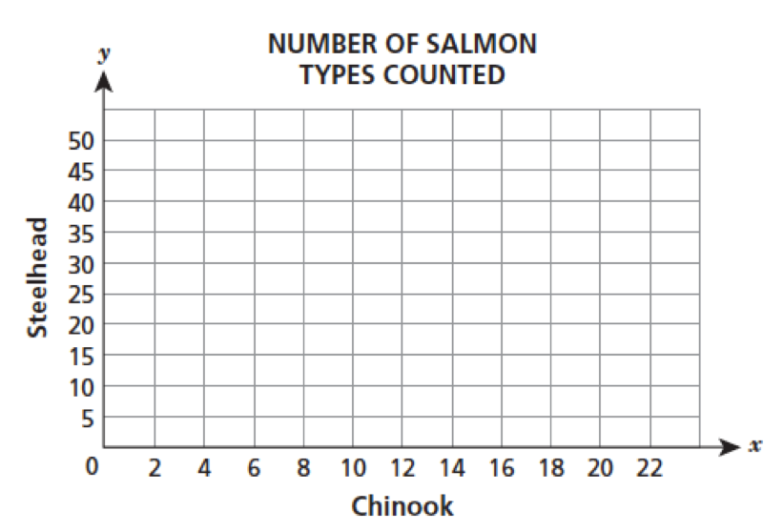
Part C:
The biologist is expecting the number of salmon to rise during salmon season. If the ratio stays the same and he expects 120 Steelhead, how many Chinook should he expect to count at the dam?
Show your work:

Answer:____________________________

