Prerequisite Skills:
- Place value
- Addition and subtraction of whole numbers and decimals
- Multiplication and division of whole numbers
- Identifying factors of whole numbers
- Identifying multiples of whole numbers
- Identifying important information in a word problem

UNIT OVERVIEW: In this unit students will explore ratios and rates. Students will apply their knowledge of multiplication and division to write and simplify ratios as well as determine equivalent rates. Students will calculate unit rate utilizing different strategies. Students will also learn how manipulate percentages. They will determine an amount from a given percentage, and then find a missing percentage from a given set of whole numbers. Students will have to apply these concepts to real world situations including, but not limited to, determining the best deal, finding a quicker pace, determine sale prices from a percent discount and determine a total whole number amount from a percentage.
Learning Target 1: I can write and simplify a ratio. 6.RP.1
 | Example
- A) Identify what is being compared and ensure that the order of the numbers matches the order of the words | 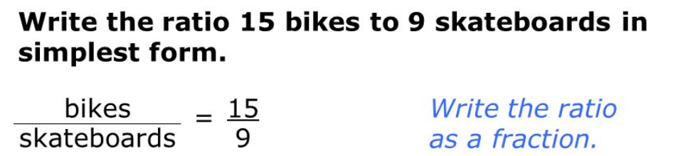
- B) Simplify by using the GCF (Unit 1) of the two numbers | 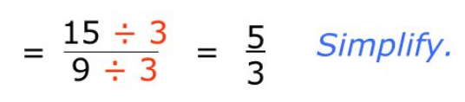

Learning Target 2: I can calculate & apply a unit rate. 6.RP.2, 6.RP.3b, 6.RP.3c
 | Example
- A) Determine a unit rate using division or a proportion | 10 ounces cost $2.50, what is the cost per ounce?
 | 0.25  10 2.50  $0.25/ounce | 10 = 1  2.5 x  10x = 2.5  10 10  x = $0.25/ounce
- B) Answer real world application problems involving unit rate. | Examples:  - Price per item  - Miles per hour  - Miles per gallon  - Minutes per mile

Learning Target 3: I can apply ratio reasoning to manipulate units to solve real world problems. 6.RP.3a, 6.RP.3d
 | Example
- A) Convert between given units to determine equivalent values. | Fluid Ounces 8 = 80  Cups 1 = x  x = 10
- B) Use ratios and proportions to compare quantities using different units of measurement. | Chris needs to fill 4 gallons of water for football practice. So far, he has filled 6 quarts. How much more water does Chris need for football practice?  Quarts 4 = x  Gallons 1 = 4  x = 16  16 – 6 = 10 more quarts needed

Learning Target 4: I can calculate the percent of a given quantity. 6.RP.3c
 | Example
- A) Determine the percent of a given number through multiplication or decimals or using a proportion | 20% of 50  20% = 0.2  50 x 0.2 = 10 | 20 = x  100 = 50  20 x 50 = 1000  1000 ÷ 100 = 10  x = 10
- B) Answer real world percent word problems | Examples:  - Percent discount, sale price  - Adding tax  - Adding a tip

Learning Target 5: I can determine a percentage given the part and the total quantity. 6.RP.3c
 | Example
- A) Determine a missing percent from a given a fraction using division and multiplication or a proportion | ²/₅ is equal to what percent?  2 ÷ 5 = 0.4  .4 x 100 = 40% | 2 = x  5 100  2 x 100 = 200  200 ÷ 5 = 40 = 40%
- B) Answer real world percent word problems | Examples:  - Using a given discount to find the % discount  - Determining a percentage completed

Learning Target 6: I can find the total quantity given the percent and a part of the total. 6.RP.3c
 | Example
- A) Determine a missing total amount from a given piece of the whole and the respective percent that it represents using division and multiplication or a proportion | 2 = 40  x 100  2 x 100 = 200  200 ÷ 40 = 5
- B) Answer real world percent word problems | Example:  - Determining an original price

Learning Target 7: I can convert between fractions, decimals, and percentages. 6.NS.7b
 | Example
- A) Use multiplication and division to convert a given number in any form into any of the other forms | ¹/₂ = 0.5 because 1 ÷ 2 = 0.5 | 0.5 = ¹/₂  because the 5 is in the tenths place, ⁵/₁₀  then, you can divide numerator and denominator by 5 and ⁵/₁₀ = ¹/₂ | ¹/₂ = 50% because 1 ÷ 2 = 0.5, and then 0.5 x 100 = 50%
- B) Understand that fractions, decimals and percentages all represent part of a whole | 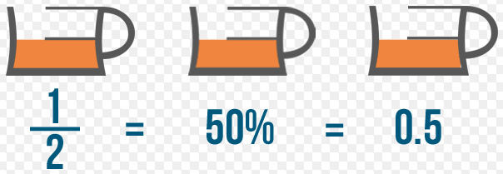
- C) Apply this knowledge to real world word problems | Examples:  - Comparing amounts presented in different forms  - Ordering given amounts presented in different forms

Vocabulary
Fraction | Rate | Unit Price | Tax
Percentage | Unit Rate | Discount | Tip
Decimal | Equivalent Rate | Sale price
Ratio | Proportion

Department Assessments
Mastery Quizzes  - Mastery Quiz #1:  - I can write and simplify a ratio.  - I can calculate an apply a unit rate.  - I can apply ratio reasoning to manipulate units to solve real world problems.  - Mastery Quiz #2:  - I can find the percent of a quantity.  - I can find the percent given the part and the total quantity.  - Mastery Quiz #3:  - I can find the total quantity given a percent and a part of the total.  - I can convert between fractions, decimals, and percentages. | Dates
Unit Test  - Part A: Department Wide: Multiple Choice questions | Date:
Performance Task  - Part B: Department Wide: Extended Response questions | Date:

Products
Culminating Project

Any adjusted dates or changes in this unit’s outline will be noted on our online gradebook. Please contact the teacher if you do not have your log in information.
Please feel free to contact the teacher with any further questions or concerns!

