Learning Targets:
I can divide a fraction by a fraction.
I can divide a whole or mixed number by a fraction.

Mastery Scoring Sheet

Overall score: __________/9 ____________%

Learning Target 1: I can divide a fraction by a fraction.
Questions: 1, 2, 4

Score: ___________/ 3 Circle: Met Did not meet

Learning Target 2: I can divide a whole or mixed number by a fraction.
Questions: 3, 5, 6

Score: ___________/ 3 Circle: Met Did not meet

Short response question: (3 pt. rubric)

Score: ___________/ 3
Correct = 3 pts. Partially Correct = 1 OR 2 pts. Incorrect = 0 pts.

Notes:
Learning Targets:
I can divide a fraction by a fraction.
I can divide a whole or mixed number by a fraction.

________ 1. What is the quotient of ¹/₂ ÷ ³/₄?
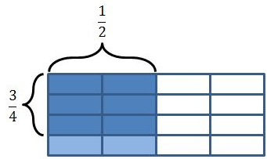
A. ³/₈ B. ²/₃ C. ⁴/₇ D. ¹/₂
________ 2. How many ¹/₈-pound burgers can be made from ⁷/₈ pounds of chop meat?
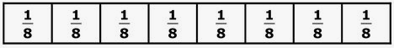
A. 7 burgers B. ⁷/₈ of a burger C. ⁸/₇ burgers D. 8 burgers

________ 3. What is the quotient of 2 ÷ ¹/₆?
A. ¹/₃ B. ²/₆ C. 12 ¹/₂ D. 12

________ 4. Amanda has ⁸/₁₀ - ounces of skittles. How many full ¹/₅ - ounce bags can she make with her candy?
A. ⁸/₅₀ bags B. 5 bags C. 4 bags D. ⁴/₂₅ bags

________ 5. The area of a rectangular park is 1¹/₂ square miles. The width of the park is ¹/₄ mile. What is the length of the park?

Think… A = lw
¹/₄ mile
1¹/₂ square miles

A. 12 miles B. ³/₈ mile C. ⁹/₁₆ miles D. 6 miles

________ 6.
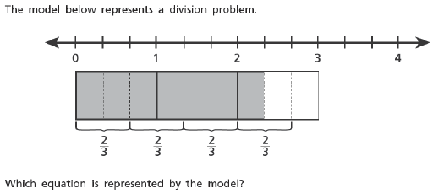
A.  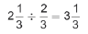 | B.  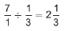 | C.  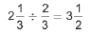 | D.  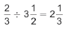

7. Regina has 3 ⁷/₈ batches of brownies. She wants to give ¹/₆ of a batch to as many friends as possible. How many friends can she equally share with?
Show your work:

Answer:_______________________________________________
Explain in complete sentences how you determined your answer, using your math vocabulary.

_____________________________________________________________________________________

_____________________________________________________________________________________

_____________________________________________________________________________________

_____________________________________________________________________________________

