Dear Parents and Guardians,

Welcome to Unit 3: Fraction Operations
Today, in class, your child received their Unit 3: Fraction Operations outline. It includes all of the learning targets taught in this unit, along with an example of each. Below you will find important information regarding your child’s new math unit, Fraction Operations. You will find the skills that your child should already have mastered in order to succeed in this unit. You will also find information about the major assignments that will affect your child’s grade for this unit.
Prerequisite Skills:
- Prime and composite numbers
- Identifying factors of whole numbers
- Identifying multiples of whole numbers
- Multiplication of multi-digit whole numbers
- Division of multi-digit whole numbers
If your child needs extra practice in any of these areas listed above, please contact us so that we can provide extra resources to assist your child.
Mastery Quizzes: 50 pts. each
Mastery quizzes are short quizzes that assess 2 – 3 learning targets. Your child will be given this quiz once the learning targets have been taught in class. The best way to prepare for these quizzes is by completing classwork and homework. If your child is struggling with homework assignments please contact us, or have your child attend an extra help session.
- Mastery Quiz 1: ____________ will assess the following learning targets:
  - I can add and subtract fractions.
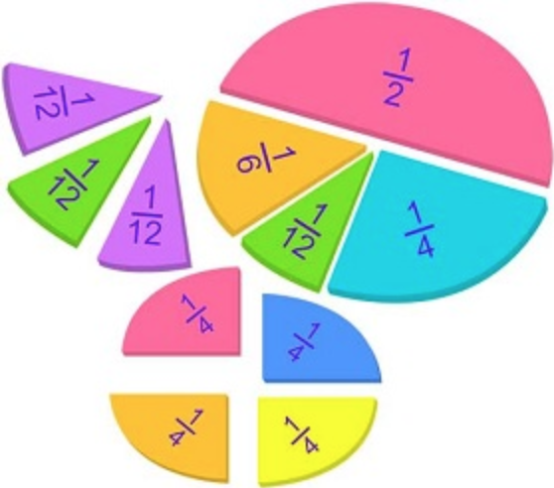
  - I can add and subtract mixed numbers.
  - I can multiply fractions and mixed numbers.
- Mastery Quiz 2: ____________ will assess the following learning targets:
  - I can divide a fraction by a fraction.
  - I can divide a whole or mixed number by a fraction.
- Mastery Quiz 3: ____________ will assess the following learning targets:
  - I can divide a fraction by a whole or mixed number.
  - I can solve real world problems involving fractions.

Unit Test: 100 pts. Approximate date:________________________
A multiple-choice exam based on the learning targets in the unit. Please review class notes and practice problems to prepare for the exam.

Performance Task: 100 pts.: Approximate date:_______________________
This is an in-class assessment. It is a multi-step word problem, where students apply the math concepts to real life situations. It is similar to the kind of questions students will see on the final day of the NYS assessment.

Culminating Project: 100 pts.
The culminating project will be assigned in the middle of the unit. It will not be due until the end of the unit. It will assess all learning targets. You will be able to access this on our online gradebook.

Learning Activities
Your child will be completing a variety of learning activities in class that reflect the learning targets for Unit 3. These will be graded, and you will be able to track your child’s progress online.

Thank you for your continued support!
-----------------------------------------------------------------------------------------------------------------------------------------------------------
Unit 3 Clear Expectations Letter
Student Name:______________________________________________ Class:_________________

Parent/Guardian Signature:___________________________________________________________________

FOR TEACHER USE: Date returned:________________________

