Name: _______________________________________________ Class: ____________ Date:____________ M
6th Unit 3: Fraction Operations Performance Task
A section of a rectangular floor is covered with square floor tiles, as shown below. Each square tile has a side length of $\frac{1}{3}$ foot.
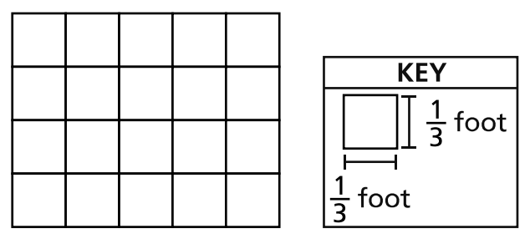
Part A:
What is the area, in square feet, of the section of rectangular floor that is covered with floor tiles?
Show your work:

Answer:_____________________________________
Part B:
The floor tiles cost $1.25 per square foot. What is the total cost of the tiles for the floor?
Show your work:

Answer:_____________________________________
Explain how you arrived at your answer to Part A:

________________________________________________________________________________

________________________________________________________________________________

________________________________________________________________________________

________________________________________________________________________________

________________________________________________________________________________

