Name: _________________________________________ Class:_________ Date:____________H
6th Unit 4: Decimal Operations Performance Task
Use the following information to help you answer question:
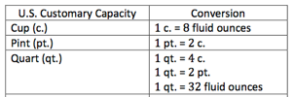
There are three stores offering different deals on orange juice. Listed below is the sale price, and quantity for each store. Determine the unit price of the orange juice at each store.

Store | Price | Amount
Fairway | $5.85 | 15 fl. Oz.
Shoprite | $12.50 | 2 pt.
Walgreens | $8.32 | 3 c.
Show your work:
Fairway | Shoprite | Walgreens
Complete the table:
Store | Price | Amount | Unit Price
Fairway | $5.85 | 15 fl. Oz.
Shoprite | $12.50 | 2 pt.
Walgreens | $8.32 | 3 c.
Which store is offering the best deal on orange juice?

Answer: ____________________________________________________

