Prerequisite Skills:
- Place value
- Addition, subtraction, multiplication & division of whole numbers
- Unit rate
- Determining the percent of a quantity
- Determining the total amount from a percentage
- Determining a percentage from a fraction

UNIT OVERVIEW: In this unit students will add, subtract, multiply and divide decimals. Students must be able to complete these operations fluently. Students will have to apply their knowledge of computation with decimals to fluently solve real world word problems with decimals. Students will extend their knowledge of equivalent ratios/rates and unit rate from Unit 2, and complete more complex application problems. Students will have to apply their knowledge of percentages to real world situations including, but not limited to, determining the best deal, finding a quicker pace, determine sale prices from a percent discount and determine a total amount number amount from a percentage.
Learning Target 1: I can add and subtract decimals. 6.NS.3
 | Example
- A) Correctly identify and line up place values to create an addition/subtraction equation | 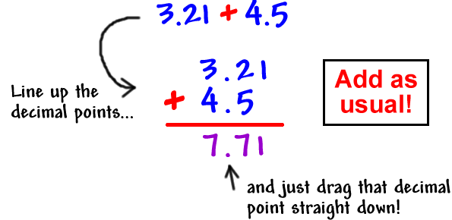
- B) Correctly add or subtract the given decimals

Learning Target 2: I can multiply decimals. 6.NS.3
 | Example
- A) Accurately multiply the digits in the given equation | 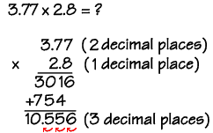
- B) Loop the decimal the correct number of times in the product

Learning Target 3: I can divide a decimal by a whole number. 6.NS.3
 | Example
- A) Divide the given number precisely | 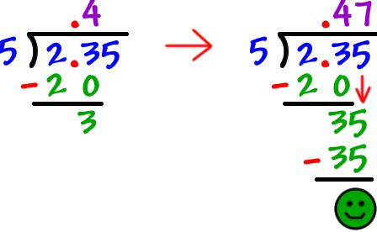
- B) Correctly place the decimal in the quotient

Learning Target 4: I can divide a whole number by a decimal. 6.NS.3
 | Example
- A) Move the decimal point the proper number of times to correctly create the equation | 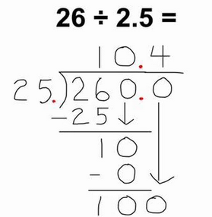
- B) Accurately divide the given numbers

Learning Target 5: I can divide a decimal by a decimal. 6.NS.3
 | Example
- A) Move the decimal point the proper number of times to correctly create the equation | 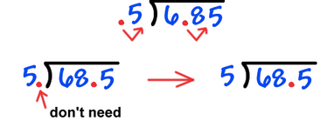
- B) Accurately divide the given numbers | 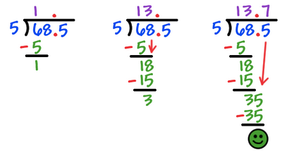
- C) Correctly place the decimal in the quotient, if necessary

Learning Target 6: I can identify the appropriate operation to solve a real world problem with decimals. MP.1, MP.7
 | Example
- A) Use math vocabulary and/or real life applications to select the correct operation and create an accurate number sentence; especially involving subtraction and division where the order matters | Recognizing key words…  Sum, difference, product, quotient and real life application of those words  Identifying what the first number should be when subtracting or dividing

Learning Target 7: I can solve real world unit rate problems involving decimals. 6.RP.3a
 | Example
- A) Determine a unit rate using division or a proportion | 10 ounces cost $2.50, what is the cost per ounce?
 | 0.25  10 2.50  $0.25/ounce | 10 = 1  2.5 x  10x = 2.5  10 10  x = $0.25/ounce
- B) Answer real world application problems involving unit rate. | Examples:  Price per item; Miles per hour; Miles per gallon; Minutes per mile

Learning Target 8: I can solve real world percent problems. 6.RP.3a
 | Example
- A) Apply their knowledge of finding the…  - Percent of a number  - Total percent from a given fraction  - Missing part from a given total and percentage  And utilize this information to answer a real world word problem | Using a given discount to find the % discount  Determining a percentage completed  Determining an original price  Percent discount, sale price  Adding tax  Adding a tip

Vocabulary
Place value | Percentage | Tax | Discount
Decimal point | Operation | Mark up | Tip
Ratio | Rate | Unit Rate | Equivalent Rate

Department Assessments
Mastery Quizzes  - Mastery Quiz #1:  - I can add and subtract decimals  - I can multiply decimals  - Mastery Quiz #2:  - I can divide a decimal by a whole number.  - I can divide a whole number by a decimal.  - I can divide a decimal by a decimal.  - Mastery Quiz #3:  - I can identify the correct operation to solve a word problem with decimals.  - I can solve real world unit rate problems with decimals.  - I can solve real world percent problems. | Dates
Unit Test  - Part A: Department Wide: Multiple Choice | Dates
Performance Task  - Part B: Teacher Created: Extended Response | Dates

Products
Culminating Project
Any adjusted dates or changes in this unit’s outline will be noted on our online gradebook. Please contact the teacher if you do not have your log in information.
Please feel free to contact the teacher with any further questions or concerns!

