Learning Targets:
I can plot coordinate pairs on a coordinate plane.
I can determine a pattern from a table or graph.
I can identify the dependent and independent variable and describe how they are related.

Mastery Scoring Sheet

Overall score: __________/12 ____________%

Learning Target 1: I can plot coordinate pairs on a coordinate plane.
Questions: 7, 8, 9

Score: ___________/ 3 Circle: Met Did not meet

Learning Target 2: I can identify a pattern from a table or graph.
Questions: 1, 3, 5

Score: ___________/ 3 Circle: Met Did not meet

Learning Target 3: I can identify the dependent and independent variable and describe how they are related.
Questions: 2, 4, 6

Score: ___________/ 3 Circle: Met Did not meet

Short response question: (3 pt. rubric)

Score: ___________/ 3
Correct = 3 pts. Partially Correct = 1 OR 2 pts. Incorrect = 0 pts.

Notes:
Learning Targets:
I can plot coordinate pairs on a coordinate plane.
I can determine a pattern from a table or graph.
I can identify the dependent and independent variable and describe how they are related.

________1. Consider the table below:
Theme Park
Number of Rides (r) | 10 | 15 | 20 | 25 | 30
Cost (c) | $25 | $37.50 | $50 | $62.50 | $75
Based on the table, how much would it cost (c) for 40 riders (r) to get on the ride?
A. $100 B. $87.50 C. $105.50 D. $90

________ 2. Consider the following research study:
A research study compared the years of education completed to the average salary a person makes.
Which of the following correctly identifies the two variables in the study?
A. research study and years of education B. people working and years of education
C. years of education and research study D. years of education and average salary

_________3. Based on the graph, what is the pattern shown between the hours of travel and the miles traveled?
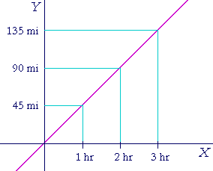
Traveling to Albany

A. as the hours increased by 1,
the miles increased by 50

B. as the hours increased by 1,
the miles increased by 45

C. as the hours increased by 1,
the miles increased by 90

D. as the hours increased by 90,
the miles increased by 2

________ 4. Based on the data table, identify the correct relationship between the two variables.
Ski Rentals in Buffalo
Number of Skis | 5 | 10 | 15 | 20
Rental Cost ($) | 255 | 505 | 755 | 1005
A. the rental cost ($) is the dependent variable and the number of skis is the independent variable
B. the number of skis is the dependent variable and the rental cost ($) is the independent variable
C. Buffalo is the dependent variable and the number of skis is the independent variable
D. the number of skis is the dependent variables and Buffalo is the independent variable
_________ 5. Points F, G, and H are represented on the grid shown below.
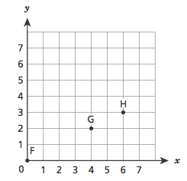

Which statement is true for each of the points?
A. The x-coordinate is $\frac{1}{2}$ the y-coordinate
B. the x-coordinate is 2 times the y-coordinate
C. the x-coordinate is 2 more than the y-coordinate
D. the x-coordinate is 3 more than the y-coordinate

________6. A survey found that less people would order pizza for lunch if the price of a slice of pizza was raised by $0.10 each. Which of the following correctly identifies the relationship between the two variables?
A. the price of the pizza depends on the survey
B. the survey depends on the people that like to eat pizza
C. the number of people ordering pizza for lunch depends on the price of the pizza
D. the slices of pizza depends on the survey

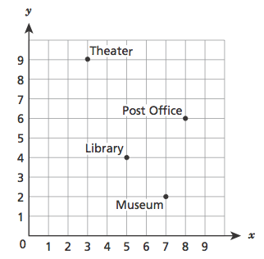
________7. The points plotted on the coordinate grid below show different locations in a city. The grid lines represent the city’s streets.

The city plans to build a parking lot at the location represented by the coordinates (8, 4). Which building is the shortest driving distance from the parking lot?

A. theater
B. library
C. museum
D. post office

________8. What is the x-coordinate of point P on the coordinate grid?
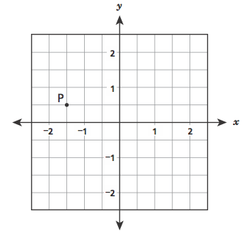

A. $-1\frac{1}{2}$
B.$\frac{1}{2}$
C. $-\frac{1}{2}$
D.$1\frac{1}{2}$

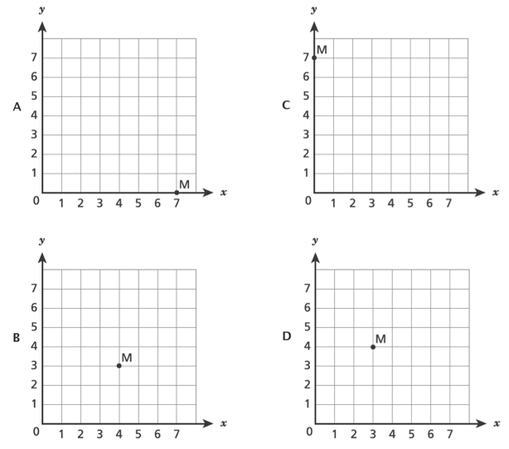
________9. Which coordinate grid shows point M plotted at (4, 3)?

10. Based on the table, how many sides, n, would there be if the sum of the interior angles, s, is 1,080 degrees?
Polygons
Number of sides (n) | 3 | 4 | 5 | 6 | 7
Sum of the interior angles (s) | 180 degrees | 360 degrees | 540 degrees | 720 degrees | 900 degrees
Show your work:

Answer:_____________________________________

