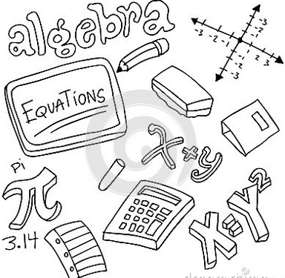
Dear Parents and Guardians,

Welcome to Unit 5: Expressions and Equations
Today, in class, your child received their Unit 5: Expressions and Equations outline. It includes all of the learning targets taught in this unit, along with an example of each. To begin, your child will review some graphing topics that should have been taught in 5th grade. In this unit, your child will begin algebra. Students will continue to work with the order of operations, as well as completing all four operations with decimals and fractions. Students will be introduced to the concept of a variable and how it is used in expressions and equations
Prerequisite Skills:
- Plotting points on a coordinate plane
- addition, subtraction, multiplication and division of whole numbers
- addition, subtraction, multiplication and division of fractions (unit 3)
- addition, subtraction, multiplication and division of decimals (unit 4)
- order of operations
If your child needs extra practice in any of these areas listed above, please contact us so that we can provide extra resources to assist your child.
Mastery Quizzes: 50 pts. each
Mastery quizzes are short quizzes that assess 2 – 3 learning targets. Your child will be given this quiz once the learning targets have been taught in class. The best way to prepare for these quizzes is by completing classwork and homework. If your child is struggling with homework assignments please contact us, or have your child attend an extra help session.
- Mastery Quiz #1: ____________ will assess the following learning targets:
- I can plot coordinate pairs on a coordinate plane.
- I can identify a pattern from a table or graph.
- I can identify the dependent and independent variable and describe how they are related.
- Mastery Quiz #2: ____________ will assess the following learning targets:
- I can evaluate a numerical or algebraic expression.
- I can write a numerical or algebraic expression to represent a given situation.
- I can generate equivalent expressions.
- Mastery Quiz #3: ____________ will assess the following learning targets:
- I can solve a 1-step or 2-step algebraic equation.
- I can create a 1-step or 2-step algebraic equation from a given word problem.
- I can solve and graph a 1-step or 2-step algebraic inequality.

Unit Test: 100 pts. Approximate date:_______________________________
Your student to review his or her notes to study for this exam.

Performance Task: 100 pts.: Approximate date:____________________________
This is an in-class assessment. It is a multi-step word problem, where students apply the math concepts to real life situations. It is similar to the kind of questions students will see on the final day of the NYS assessment.

Culminating Project: 100 pts.
The culminating project will be assigned in the middle of the unit. It will not be due until the end of the unit. It will assess all learning targets.

Learning Activities
Your child will be completing a variety of learning activities in class that reflect the learning targets for Unit 5. These will be graded, and you will be able to track your child’s progress online.
Thank you for your continued support!
-----------------------------------------------------------------------------------------------------------------------------------------------------------
Unit 5 Parent Letter
Student Name:______________________________________________ Class:_________________

Parent/Guardian Signature:___________________________________________________________________

FOR TEACHER USE: Date returned:_______________________

