Name:______________________________________________ Class:___________ Date:__________
6th Grade Unit 5: Expressions and Equations Post Test
__________ 1. The warmest temperature this week was -2°F. Which graph represents this week’s situation?
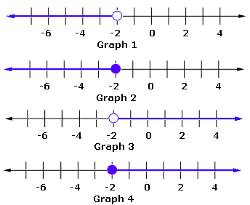
- Graph 1
- Graph 2
- Graph 3
- Graph 4

__________ 2. Evaluate the following expression: 4s + 17 when s = 12
- 65
- 33
- 29
- 20

__________ 3. Use the chart below to determine the pattern and identify how many hot dogs would you need for 7 students?
# of students | 3 | 4 | 5 | 6 | 7
Hot dogs | 6 | 8 | 10 | 12 | ?
- 11
- 13
- 14
- 15

__________ 4. Which equation has the solution x = 2?
- 2x – 3 = 19
- 3x + 2 = 8
- 4x – 4 = –4
- 5x + 1 = 10

__________ 5. Mr. Kelly is analyzing his class data. He notices that the students that spend the most time on www.thinkthroughmath.com also are earning the highest scores on the mastery quizzes. Which is the independent variable?
- The time spent on think through math
- The quiz scores earned
- Class data
- Mr. Kelly

__________ 6. Jeanna has a 3-year-old brother and a 5-year-old brother. Jeanna is four years younger than the sum of the ages of her brothers. How old is Jeanna?
- (3 + 5) x 4
- (3 + 5) + 4
- (3 + 5) – 4
- 3 x 5 + 4

__________ 7. Which of the following is an example of the distributive property?
- 3 + 4 + 5 = 4 + 3 + 5
- 3(4 + 5) = 3(4) + 3(5)
- (3 + 4) + 5 = 3 + (4 + 5)
- 4 x 5 = 20

__________ 8. Mei made b braided bracelets. She split them evenly among 8 gift boxes. Choose the expression that shows how many bracelets were in each box.
- 8b
- b - 8
- b + 8
- $\frac{b}{8}$
__________ 9. Solve the following inequality: 2x + 2 > 8
- x > 3
- x < 3
- x > 2
- x < 2

__________ 10. Evaluate the following expression: y² + 5 when y = 5
- 15
- 30
- 10
- 20

__________ 11. Which of the following is an example of the commutative property?
- a(b + c) = ab + ac
- (a + b) + c = a + (b + c)
- a + 0 = a
- ab = ba

__________ 12. Solve. 0.3r = 2.1
- r = 0.7
- r = 1.8
- r = 7
- r = 18

__________ 13. Jason has a coupon for $2.50 off any electronic book from an online book store. If the original price, in dollars, of an electronic book is p and the discounted price, in dollars, is d, which table shows the relationship between p and d?

p | 3.00 | 4.00 | 5.00 | 6.00
d | 0.50 | 1.50 | 2.50 | 3.50
A.

B.

C.

D.
p | 3.00 | 4.00 | 5.00 | 6.00
d | 5.50 | 6.50 | 7.50 | 8.50

p | 3.00 | 4.00 | 5.00 | 6.00
d | 2.50 | 2.50 | 2.50 | 2.50

p | 3.00 | 4.00 | 5.00 | 6.00
d | 7.50 | 10.50 | 12.50 | 15.00

__________ 14. Pedro earned $40 less than twice than what Augusto made. If Augusto earned x dollars, what did Pedro earn?
- 2x – 40
- 40 - 2x
- 40 + 2
- 2(40) – x

__________ 15. Which of the following expressions is equivalent to 3.5m² + 1.4m² – 1.2m² + 0.5m – 3.3?
- 3.7m² + 0.5m – 3.3
- 4.9m² – 0.5m – 3.3
- 2.3m² – 1.2m – 0.5m
- 1.2m² + 0.5m + 3.3

__________ 16. Solve the following inequality: 3y – 5 < 10
- y > 5
- y < 5
- y > 8
- y < 8

__________ 17. Evaluate the following expression: 2k – 17 + 6 when k = 15
- 13
- 7
- 19
- 6

__________ 18. Solve: 8.63 + x = 11.001
- 19.631
- 10.138
- 3.471
- 2.371

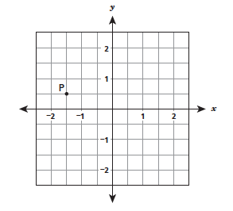
__________ 19. What is the x-coordinate of point P on the coordinate grid?

- -1¹/₂
- -¹/₂
- ¹/₂
- 1¹/₂

__________ 20. To earn some extra money Gabriella decided to babysit after school. She is charging $8 per hour. Which is the dependent variable?
- The amount of hours worked is the dependent variable.
- The amount of money earned is the dependent variable.
- The amount of hours worked is the independent variable.
- The amount of money earned is the independent variable.

__________ 21. David says, “I have 3 more than five times as many baseball cards as Tao.” Tao has x baseball cards. How many baseball cards does David have in his collection?
- 3x+ 5x
- 3x + 5
- 5x + 3
- 5(x+3)

__________ 22. Which pair of expressions below is equivalent?
- 7(2x) and 9x
- 3x + 5x and 15x
- 4(2x – 6) and 8x – 24
- x + x + x = x and x⁴

__________ 23. Cindy drew p pictures. Brennan drew 89 fewer pictures than Cindy. Brennan drew 97 pictures. Which equation represents this situation accurately?
- p + 89 = 97
- p – 89 = 97
- 89p = 97
- $\frac{p}{89}$ = 97

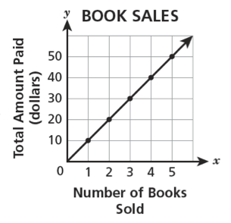
__________ 24. Which of the following correctly describes the relationship between the number of books sold and the total amount paid?

- For every 10 books sold, 10 dollars was paid
- For every 10 books sold, 1 dollar was paid
- For every book sold, 1 dollar was paid
- For every book sold, 10 dollars was paid

__________ 25. A shelf has four books on it. The weight, in pounds, of each of the four books on the shelf is listed below:
2.5, 3.2, 2.7, 2.3
Which inequality represents the weight, w, of any book chosen from the shelf?
- w > 2.3
- w < 2.4
- w > 3.2
- w < 3.3

__________ 26. Points F and G have been plotted on the coordinate plane below.
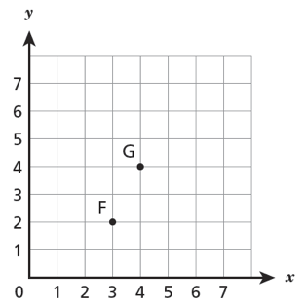

Point G and point H are the same distance from point F. Which coordinates could be the location of point H?

- (2, 4)
- (4, 2)
- (5, 1)
- (2, 5)

__________ 27. Mr. Kouvatsos spent $4.50 on admission to a basketball game. He also spent some money at the concession stand. He purchased p bags of popcorn for $1.25 each. In all, Mr. Kouvatsos spent 16.25 at the basketball game. Which equation represents this?
- p + 1.25 + 4.50 = 16.25
- 4.50p + 1.25 = 16.25
- 1.25p + 4.5 = 16.25
- 1.25p + 4.5p = 16.25

__________ 28. Joseph says the following: “Four less than the product of seven and c”. Represent what Joseph said.
- 4 – 7c
- 7c – 4
- $\frac{c}{7}$ – 7
- 4c + 7

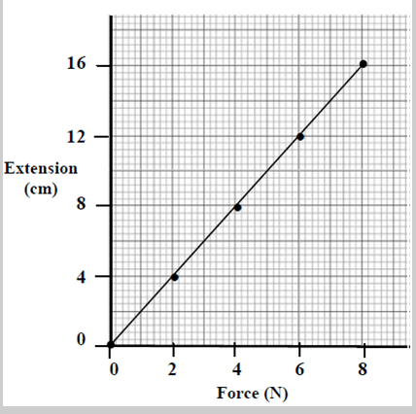
__________ 29. Which comparison best describes the graph?

- The force is twice the extension.
- The force is one fourth of the extension.
- The extension is one fourth of the force.
- The extension is twice the force.

__________ 30. Jeremy is helping his uncle by walking his dog. He makes $9.00 per walk. He wants to save up for a new Playstation VR. To motivate himself, Jeremy wants to create a graph. What variable should Jeremy put on the y-axis?
- Jeremy should put the number of walks on the y-axis because it is the independent variable.
- Jeremy should put the number of playstation games on the y-axis because it is the dependent variable.
- Jeremy should put the number of walks on the y-axis because it is in dependent variable
- Jeremy should put the amount of money earned on the y-axis because it is the dependent variable.

__________ 31. Alex starts with $5 and saves $10 each week. Nora start with $14 and saves $10 each week. What is the relationship between how much money Nora has at the end of each week compared to Alex, where Alex has saved x dollars?
 | Alex’s Savings | Nora’s Savings
Start | $5 | $14  A. x + 9  B. 2x  C. x – 14  D. 2x + 14
1st Week | $15 | $24
2nd Week | $25 | $34
3rd Week | $35 | $44
4th Week | $45 | $54
5th Week | $55 | $64

__________ 32. Jake scored x points in the first basketball game. He scored 2 fewer points in the second game. His teammate, Jack, scored 2y points in the first game and 4 more than twice as many points in the second game. Jake and Jack scored a total of 108 points in game 2. Which equation below represents the total number of points scored by both players in the second game?
- 2x – 2 + 2(2y + 4) = 108
- x² – 4y + 8 = 108
- 2x + 6y + 2 = 108
- 2x + 6y - 2 = 108

__________ 33. Lyvia and Lynette own a company that sells wagons. The amount they pay each of their sales employees (in dollars) is given by the expression 12h + 30w where h is the number of hours worked and w is the number of wagons sold. What is the amount paid to an employee that works 6 hours and sells 3 wagons?
- $216.00
- $51.00
- $132.00
- $162.00

__________ 34. The table below shows how many Chinook Salmon were caught over the course of several days. Which equation represents the relationship between the number of days, x, and the number of Chinook Salmon caught, Chinook Salmon caught, y?
Number of Days, x | Chinook Salmon Caught, y
2 | 8
3 | 12
5 | 20
- x = 4y
- y = 4x
- y = 4 + x
- y = 2x

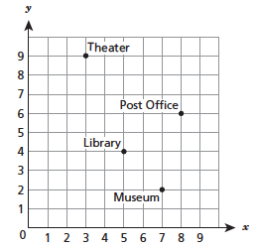
__________ 35. The points plotted on the coordinate grid below show different locations in a city. The grid lines represent the city’s streets.

What are the coordinates of the Library?
- (4, 5)
- (5, 4)
- (7, 2)
- (8, 6)

__________ 36. Chakan worked at the warehouse after school. He earned $9.25 per hour stacking boxes. Which equation correctly relates Chakan’s total earnings, d, to the number of hours he worked, h?
- d = 9.25h
- h = 9.25d
- d = $\frac{9.25}{h}$
- h = $\frac{9.25}{d}$

__________ 37. The weight of an object on the moon, m, is about ¹/₆ of the object’s weight on Earth, e. Which equation represents the approximate weight of an object on the moon in terms of the object’s weight on Earth?
- m = $\frac{1}{6}$ + e
- m = $\frac{e}{6}$
- m = 6 + e
- m = 6e

__________ 38. Which expression is represented by the phrase, “the square of y decreased by the quotient of 28 and 7”?
- $\frac{28}{7}$ – y²
- y² – $\frac{28}{7}$
- $\frac{28}{7}$_{– y}²
- $\frac{28}{y^{2}-7}$

__________ 39. Graph the solution set for 3 > m
A.
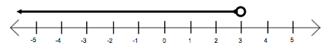
B.
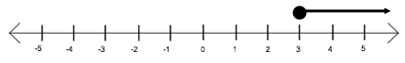
C.
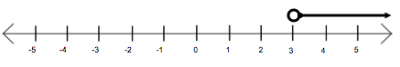
D.
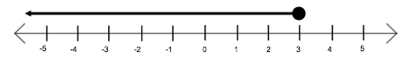

__________ 40. Which value or values for the variable c from the set below will make 5.6 + 0.4c ≤ 6c true?
{0, 0,875, 1, 2.5}
- only 2.5
- 1 and 2.5
- 0.875, 1 and 2.5
- all values in the set

