Prerequisite Skills:
- Plotting points on a coordinate plane
- addition, subtraction, multiplication and division of whole numbers
- addition, subtraction, multiplication and division of decimals (unit 4)
- order of operations
UNIT OVERVIEW: In this unit students will begin with extending graphing skills that were taught at the end of 5th grade. Students will then dive into algebra. The order of operations will be reviewed so that students can evaluate expressions. Students will learn to solve for the value of a variable in an equation and an inequality using inverse operations. Students will learn how to graph the solution to an inequality on a number line. Finally, students will also be expected to be able to create expressions and equations that include a variable from a given situation.
Learning Target 1: I can plot coordinate pairs on a coordinate plane. 6.NS.C.8, 6.EE.C.9
A) Identify parts of a graph (axes, quadrants, intervals.

Learning Target 2: I can identify a pattern from a table or graph. 6.NS.C.8, 6.EE.C.9
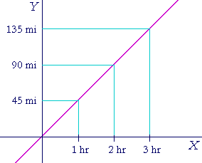
Example
- A) Identify the pattern shown in a table or graph by determining the relationship among the numbers using multiplication and division. | How far will he have  traveled after 4 hours?

Learning Target 3: I can identify the dependent and independent variable and describe how they are related. 5.OA.B.3
 | Example
- A) Identify which variable is independent | Time (h) 1 2 3 4  Distance (mi) 65 130 195 260  Which variable will change no matter what?
- B) Determine how the dependent variable changes in relationship to the independent variable

Learning Target 4: I can evaluate a numerical or algebraic expression.
6.EE.A.1, 6.EE.A.2, 6.EE.B.6
 | Example
- A) Substitute a given value into an algebraic expression accurately | 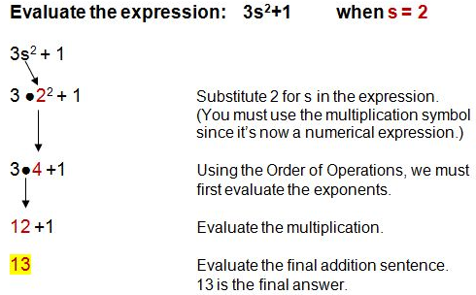
- B) Follow the order of operations in order to evaluate an expression correctly

Learning Target 5: I can write a numerical or algebraic expression to represent a given situation. 6.EE.A.1, 6.EE.A.2, 6.EE.B.6
 | Example
- A) Use key words from the problem, and background knowledge to accurately represent the situation | 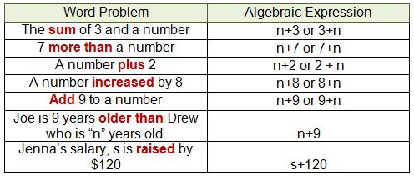

Learning Target 6: I can generate equivalent expressions. 6.EE.A.2, 6.EE.A.3
 | Example
- A) Utilize the distributive property to create equivalent expressions | 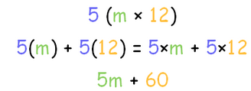
- B) Use substitution to prove that two expressions are equivalent | Is 5m + 30 the same as 5(m + 6)  If m = 2 then…  5(2) + 30 = 40  5(2 + 6) = 5 x 8 = 40  so they are equal

Learning Target 7: I can solve a 1-step or 2-step algebraic equation. 6.EE.A.4, 6.EE.A.5, 6.EE.B.6
 | Example
- A) Identify which inverse operations are necessary to isolate the variable | 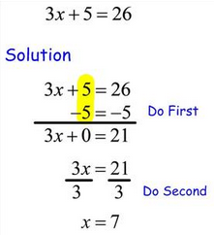
- B) Correctly work backwards to solve for the variable

Learning Target 8: I can create a 1-step or 2-step algebraic equation from a given word problem. 6.EE.A.7, 6.EE.B.6
 | Example
- A) Use key words from the problem, and background knowledge to accurately represent the situation | A taxi cab charges an initial fee of $2.50 and an additional $1.75 per mile. Write an equation to represent the cost of a trip if c = total cost and m = number of miles.  c = 2.50 + 1.75m

Learning Target 9: I can solve and graph a 1-step or 2-step algebraic inequality.
6.EE.A.8, 6.EE.B.6
 | Example
- A) Identify which inverse operations are necessary to isolate the variable | 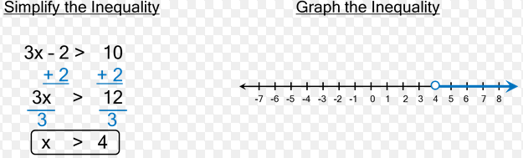
- B) Correctly work backwards to solve for the variable
- C) Accurately graph the solution on a number line

Vocabulary
Expression | Equation | Order of operations | Independent variable
Variable | Operation | Inequality | Dependent variable
Inverse operation | y-axis | x-axis | Evaluate

Department Assessments
Mastery Quizzes  - Mastery Quiz #1:  - I can plot coordinate pairs on a coordinate plane  - I can identify a pattern from a table or graph.  - I can identify the dependent and independent variable and describe how they are related.  - Mastery Quiz #2:  - I can evaluate a numerical or algebraic expression.  - I can write a numerical or algebraic expression to represent a given situation.  - I can generate equivalent expressions.  - Mastery Quiz #3:  - I can solve a 1-step or 2-step algebraic equation.  - I can create a 1-step or 2-step algebraic equation from a given word problem.  - I can solve and graph a 1-step or 2-step algebraic inequality. | Dates
Unit Test  - Part A: Department Wide: Multiple Choice | Dates
Performance Task  - Part B: Teacher Created: Extended Response | Dates

Products
Culminating Project
Any adjusted dates or changes in this unit’s outline will be noted on our online gradebook. Please contact the teacher if you do not have your log in information.
Please feel free to contact the teacher with any further questions or concerns!

