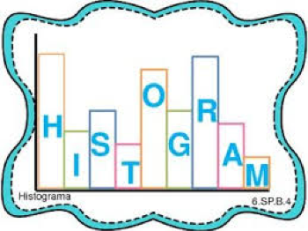
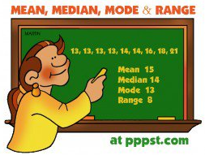

Dear Parents and Guardians,
Welcome to Unit 7: Statistics

Today, in class, your child received their Unit 7: Statistics outline. It includes all of the learning targets taught in this unit, along with an example of each. To begin, we will be learning about the difference between statistical and non-statistical questions. We will analyze and create examples of these questions. We will then begin to analyze data sets using the measures of center and variability. Finally, we will create frequency tables from data sets, and then exemplify the data sets using various visual representations.
Prerequisite Skills:
- multiplication and division of whole numbers
- multiplication and division of decimals (unit 4)
- inverse operations (unit 5)
If your child needs extra practice in any of these areas listed above, please contact us so that we can provide extra resources to assist your child.

Mastery Quizzes: 50 pts. each
Mastery quizzes are short quizzes that assess 2 – 3 learning targets. Your child will be given this quiz once the learning targets have been taught in class. The best way to prepare for these quizzes is by completing classwork and homework. If your child is struggling with homework assignments please contact us, or have your child attend an extra help session.
- Mastery Quiz #1:
- I can identify and/or create a statistical question.
- I can utilize data to make predictions about a population.
- Mastery Quiz #3:
- I can compute the measures of center (mean, median, mode) from a data set.
- I can describe a data set from the measures of center.
- Mastery Quiz #2:
- I can compute the measures of variability (range, quartiles, MAD) from a data set.
- I can describe a data set from the measures of variability.
- I can organize and represent data using tables, dot plots, line plots, bar graphs, histograms and box-and-whisker plots.

Unit Test: 100 pts. Approximate date:_________________________
Your student to review his or her notes to study for this exam

Performance Task: 100 pts.: Approximate date:_________________________
This is an in-class assessment. It is a multi-step word problem, where students apply the math concepts to real life situations. It is similar to the kind of questions students will see on the final day of the NYS assessment.

Culminating Project: 100 pts.
The culminating project will be assigned in the middle of the unit. It will not be due until the end of the unit. It will assess all learning targets.

Learning Activities
Your child will be completing a variety of learning activities in class that reflect the learning targets for Unit 7. These will be graded, and you will be able to track your child’s progress online.

Thank you for your continued support!
-----------------------------------------------------------------------------------------------------------------------------------------------------------
Unit 7 Parent Letter
Student Name:______________________________________________ Class:_________________

Parent/Guardian Signature:___________________________________________________________________

FOR TEACHER USE: Date returned:_______________________

