Prerequisite Skills:
- multiplication and division of whole numbers
- multiplication and division of decimals (unit 4)
- inverse operations (unit 5)

UNIT OVERVIEW: Students will begin their study of statistics during this unit. This information will be assessed on the 7th grade NYS mathematics assessments. The unit begins with analyzing statistical questions as well as determining if a sample is fairly representative of a target population. Students will find measures of center and variability in order to describe data sets. Students will create frequency tables from data sets in order to represent the data using various representations.

Learning Target 1: I can identify and/or create a statistical question. 6.SP.6, 6.SP.7
- Identifying the population
- Describing the components of a statistical question

Learning Target 2: I can utilize data to make predictions about a population. 6.SP.1
 | Example
- Identify populations, samples & outliers | 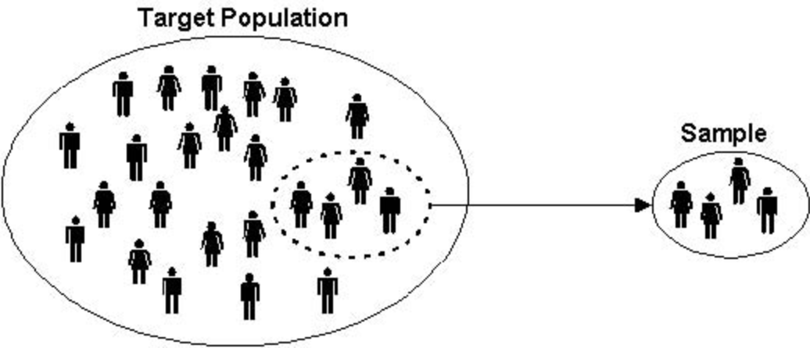
- Estimate population size based on a sample

Learning Target 3: I can compute the measures of center (mean, median, mode) from a data set. 6.SP.3
 | Example
- Identify the median from the data set | 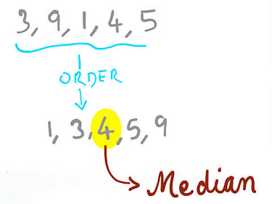  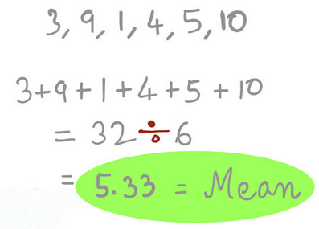  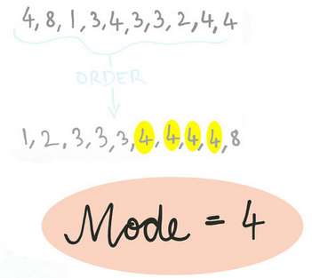
- Determine the mode from the data set
- Calculate the mean from the data set

Learning Target 4: I can describe a data set from the measures of center. 6.SP.2, 6.SP.3, 6.SP.4
- Utilizing the measures of center to generalize the data set, based on what the numerical values in the data set represented

Learning Target 5: I can compute the measure of variability (range, quartiles, MAD) from a data set. 6.SP.3
 | Example
- Compute the range of a data set | 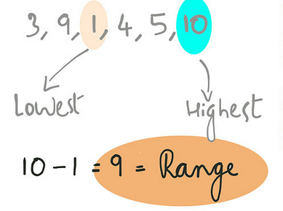
- Determine the lower and upper quartile from a data set, and use them to find the inter-quartile range | 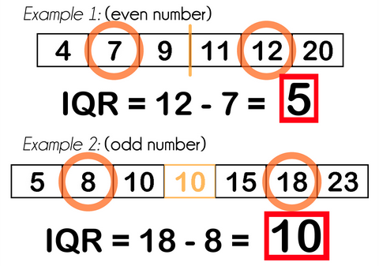
- Calculate the mean absolute deviation from a data set | 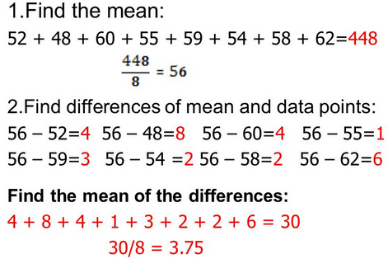

Learning Target 6: I can describe a data set from the measures of variability. 6.SP.2, 6.SP.3, 6.SP.5
Example
- Utilizing the measures of variability to generalize the data set, based on what the numerical values in the data set represented

Learning Target 7: I can organize and represent data using tables, dot plots, line plots, bar graphs, histograms and box-and-whisker plots. 6.SP.4
 | Example
- Creating a frequency table to organize data | 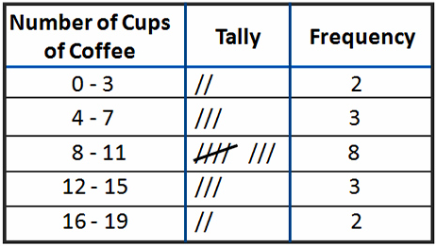
- Selecting and creating the most appropriate visual representation of the data

Vocabulary
Statistical Question | Mean | Third/Upper Quartile | Line plots
Population | Median | Mean Absolute Deviation | Dot plots
Sample | Mode | Frequency Table | Bar graphs
Convenience Sample | Range | Histogram
Random Sample | First/Lower Quartile | Box and Whisker Plot

Department Assessments
Mastery Quizzes  - Mastery Quiz #1:  - I can identify and/or create a statistical question.  - I can utilize data to make predictions about a population.  - Mastery Quiz #2:  - I can compute the measures of center (mean, median, mode) from a data set.  - I can describe a data set from the measures of center.  - Mastery Quiz #3  - I can compute the measures of variability (range, quartiles, MAD) from a data set.  - I can describe a data set from the measures of variability.  - I can organize and represent data using tables, dot plots, line plots, bar graphs, histograms and box-and-whisker plots. | Dates
Unit Test  - Part A: Department Wide: Multiple Choice | Dates
Performance Task  - Part B: Teacher Created: Extended Response | Dates

Products
Culminating Project

Any adjusted dates or changes in this unit’s outline will be noted on our online gradebook. Please contact the teacher if you do not have your log in information.
Please feel free to contact the teacher with any further questions or concerns!

