Name:_______________________________________________ Class:_________ Date:___________

**Learning Target**: I can organize and represent data using tables, dot plots, line plots, bar graphs, histograms and box plots.

**Do Now**

**Directions:** Determine the following measures from the data set shown below.

{6, 1, 3, 8, 5, 11, 1, 5}

Order the data:_________________________________

Median = ________

Q1 = ________

Q3 = ________

IQR = ________

Name:_______________________________________________ Class:_________ Date:___________

**Learning Target**: I can organize and represent data using tables, dot plots, line plots, bar graphs, histograms and box plots.

**Do Now**

**Directions:** Determine the following measures from the data set shown below.

{6, 1, 3, 8, 5, 11, 1, 5}

Order the data:_________________________________

Median = ________

Q1 = ________

Q3 = ________

IQR = ________

Name:________________________________________________ Class:____________ Date:______________

**Learning Target**: I can organize and represent data using tables, dot plots, line plots, bar graphs, histograms and box plots.

**Box and Whisker Plots/Box Plots**

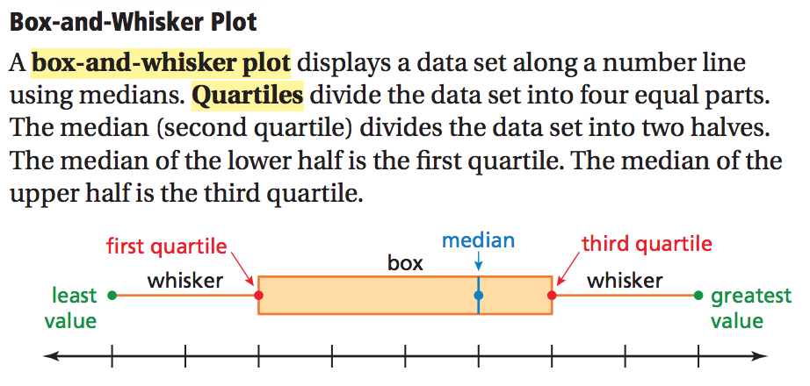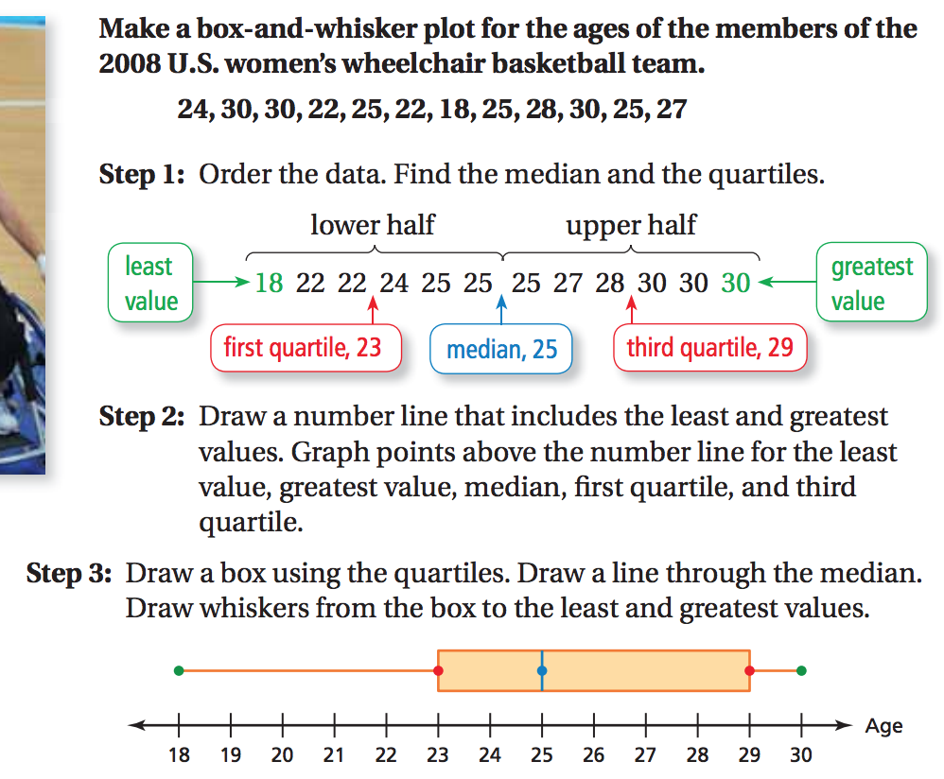

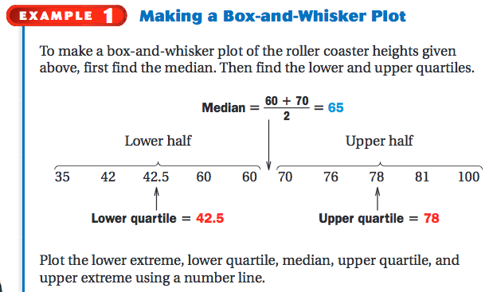

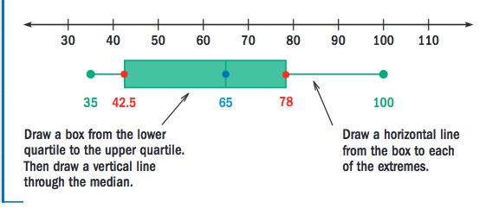

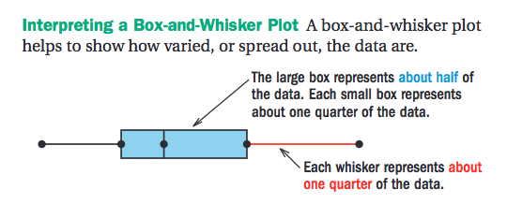

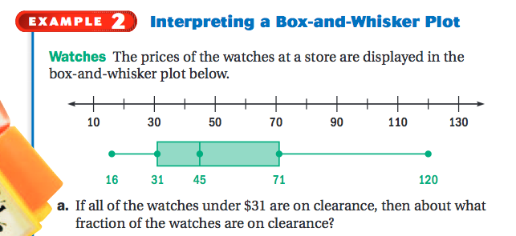

______________________________________________________________________

Screen Shot 2015-06-01 at 6

______________________________________________________________________

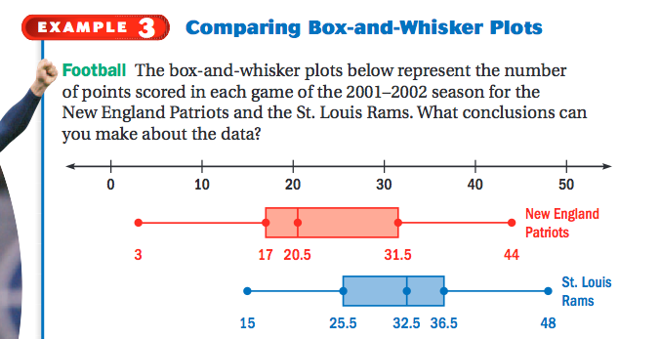

Name:_____________________________________ Class:___________ Date:_________

**Learning Target**: I can organize and represent data using tables, dot plots, line plots, bar graphs, histograms and box plots.

**Box and Whisker Plots/Box Plots**

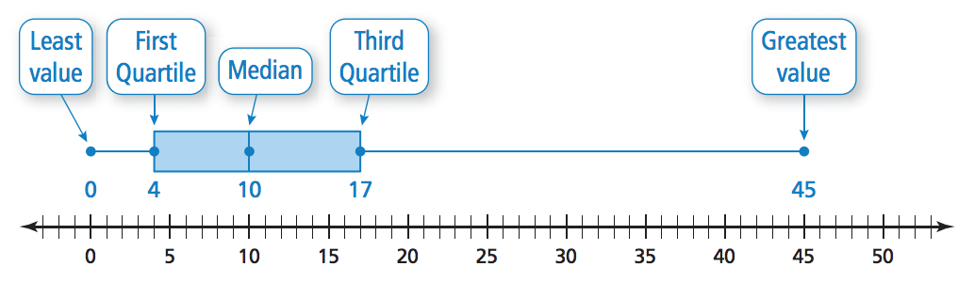

**Directions:** The accompanying box-and-whisker plot represents the scores earned on a math test. Use it to answer questions a – e.



________ a) What is the median score?

(1) 75 (2) 70 (3) 85 (4) 77

________ b) What score represents the first quartile?

(1) 55 (2) 70 (3) 100 (4) 75

________ c) What statement is *not* true about the box and whisker plot shown?

(1) 75 represents the mean score (3) 85 represents the 3rd quartile

(2) 100 represents the maximum score (4) 55 represents the minimum score

________ d) A score of an 85 on the box-and-whisker plot shown refers to:

(1) the third quartile (3) the maximum score

(2) the median (4) the mean

________ e) The data set 5, 6, 7, 8, 9, 9, 9, 10, 12, 14, 17, 17, 18, 19, 19 represents the number of hours spent on the Internet in a week by students in a mathematics class. Which box-and-whisker plot represents the data?

f) Create a box plot from the following data: 17, 29, 32, 9, 30, 14, 8, 39, 11, 32, 23

Order the data from least to greatest: ________________________________________

Minimum: _____________ Median:_______________ Maximum:______________

|  |  |
| --- | --- |
| Q1: | Q3: |

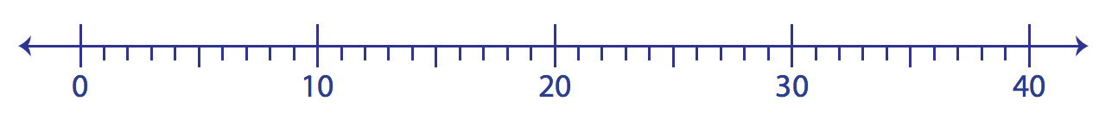

|  |  |  |
| --- | --- | --- |
| **Readiness**   * Arrived to class on time * Actively worked on the do now * Completed the do now | **Positive Contribution**   * Followed along with class notes * Followed teacher instructions | **Understanding**   * Correctly answered the five multiple choice questions |
| **/10** | **/30** | **/60** |

**Comments:**

Grade:___________________________

Name:________________________________________________ Class:____________ Date:______________

**Learning Target**: I can organize and represent data using tables, dot plots, line plots, bar graphs, histograms and box plots.

**Box and Whisker Plots/Box Plots**

**Directions:** Answer the questions below based on the box plot “Test Scores (as %) for 6th period”

**Test Scores (as %) for 6th Period**

38 72 88 96 102

1. What was the high score on the test? __________

2. What percent of the class scored above a 72? _________

3. What was the median score on the test? ____________

4. What percent of the class scored between 88 & 96?_____________

Answer the questions below based on the box plot, “Average minutes per night spent on Homework”

**Average Minutes Per Night Spent On Homework**

0 20 48 60 190

5. What percent of the students spend more than 60 minutes on homework per night? ___________

6. What is the range of the amount of minutes per night spent on homework? __________

7. What is the IQR of the data? _____________

**TV & Homework Minutes per Night**

Homework Time

0 20 48 60 190

TV Time

0 15 60 110 225

8. What percent of the sophomores watch TV for at least 15 minutes per night?_______________

9. What is the 3rd quartile for the TV time data? ____________

10. What is the range for the average minutes spent watching TV per night? ______________

11. Is the median greater for TV time or HW time? ____________________________________________