Name:_______________________________________ Class:________ Date:________
Learning Target: I can organize and represent data using tables, dot plots, line plots, bar graphs, histograms and box plots.

Do Now

Directions: Answer the following question using the box plot.
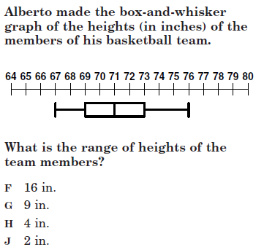

Name:_______________________________________ Class:________ Date:________
Learning Target: I can organize and represent data using tables, dot plots, line plots, bar graphs, histograms and box plots.

Do Now
Directions: Answer the following question using the box plot.
Name:_______________________________________ Class:________ Date:________
Learning Target: I can organize and represent data using tables, dot plots, line plots, bar graphs, histograms and box plots.

Video Notes:

What is the x-axis in a histogram? ________________________________

In a histogram the intervals are always of ______________________ size.

What is the y-axis in a histogram? ________________________________

What does the height of a bar in a histogram represent? _________________________

The bars in a histogram will always _________________________

----------------------------------------------------------------------------------------------------------

Follow up questions:

What is difference between the bars in a bar graph and a histogram? ___________________

_______________________________________________________________________

_______________________________________________________________________

When is it appropriate to have a gap between bars on a histogram? _____________________

_______________________________________________________________________

_______________________________________________________________________

A histogram is a type of graph that shows data in the form of a picture.

Data is facts and statistics collected to analyze or reference. When data is collected, no matter what type of data that is, it's most often put into a graph so we can visually see what the numbers are saying.

A histogram is very similar to a bar graph. The main difference between the two is that a bar graph has a single value that names each bar, and a histogram has a range of numbers that name each bar.

Example:

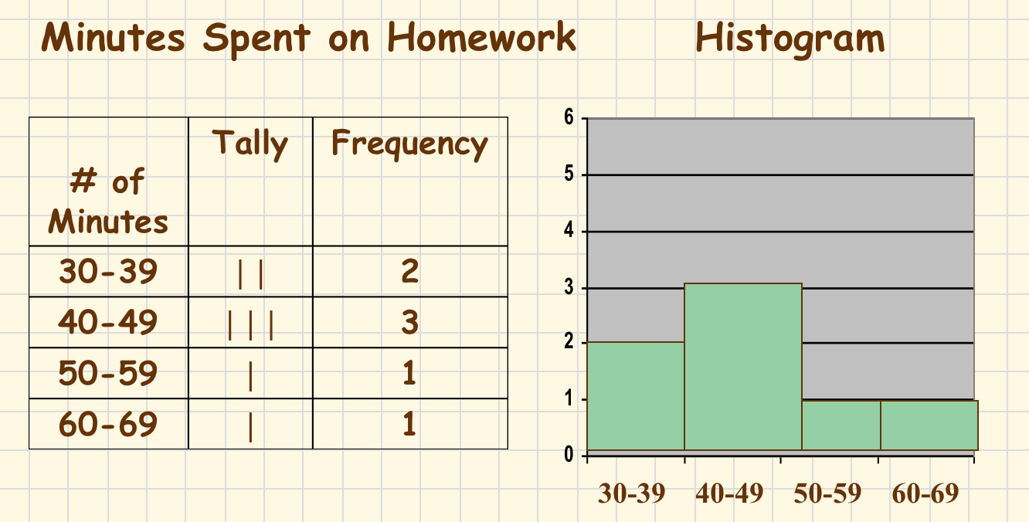

What is measures can we determine from a histogram? _____________________________

How is a histogram different from a box plot? ____________________________________

_______________________________________________________________________

_______________________________________________________________________

