Name:___________________________________________________ Class:_____________ Date:___________
Learning Target: I can organize and represent data using tables, dot plots, line plots, bar graphs, histograms and box plots.
Harry earned the following test scores in math this marking period:

65, 75, 81, 78, 90, 99, 85, 85, 85, 87, 66, 92, 97, 72, 78, 60, 72, 72
Order the data from least to greatest

__________________________________________________________________________________________

Determine the following measures based on the data set.

(1) Median:

Answer:_________________________________

(2) Mode:

Answer:_________________________________

(3) Mean

Show your work:

Answer:________________________________

(4) Range:

Show your work:

Answer:________________________________

(5) First Quartile:

__________________________________________________________________________________________

Answer:_________________________________

(6) Third Quartile:

__________________________________________________________________________________________

Answer:_________________________________

(7) Interquartile Range:

Show your work:

Answer:________________________________
(8) Construct a frequency table to be able to construct a histogram
Test Score | Frequency | Total
65 - <70
70 - <75
75 - <80
80 - <85
85 - <90
90 - <95
95 - <100

(9) Construct a histogram.

Name:___________________________________________________ Class:_____________ Date:___________
Learning Target: I can organize and represent data using tables, dot plots, line plots, bar graphs, histograms and box plots.
Alisa earned the following amounts walking dogs during 15 days in July:

15, 20, 12, 15, 8, 15, 25, 30, 15, 12, 15, 30, 20, 25, 22, 11, 10, 15, 18, 16, 15
Order the data from least to greatest

__________________________________________________________________________________________

Determine the following measures based on the data set.

(1) Median:

Answer:_________________________________

(2) Mode:

Answer:_________________________________

(3) Mean

Show your work:

Answer:________________________________

(4) Range:

Show your work:

Answer:________________________________

(5) First Quartile:

__________________________________________________________________________________________

Answer:_________________________________

(6) Third Quartile:

__________________________________________________________________________________________

Answer:_________________________________

(7) Interquartile Range:

Show your work:

Answer:________________________________
(8) Construct a frequency table to be able to construct a histogram
Money Earned | Frequency | Total
5 - <10
10 - <15
15 - <20
20 - <25
25 - <30
30 - <35

(9) On graph paper construct a histogram.

Name:_______________________________________ Class:________ Date:________
Learning Target: I can organize and represent data using tables, dot plots, line plots, bar graphs, histograms and box plots.

Exit Ticket

Directions: Create a histogram from the frequency table displayed below.

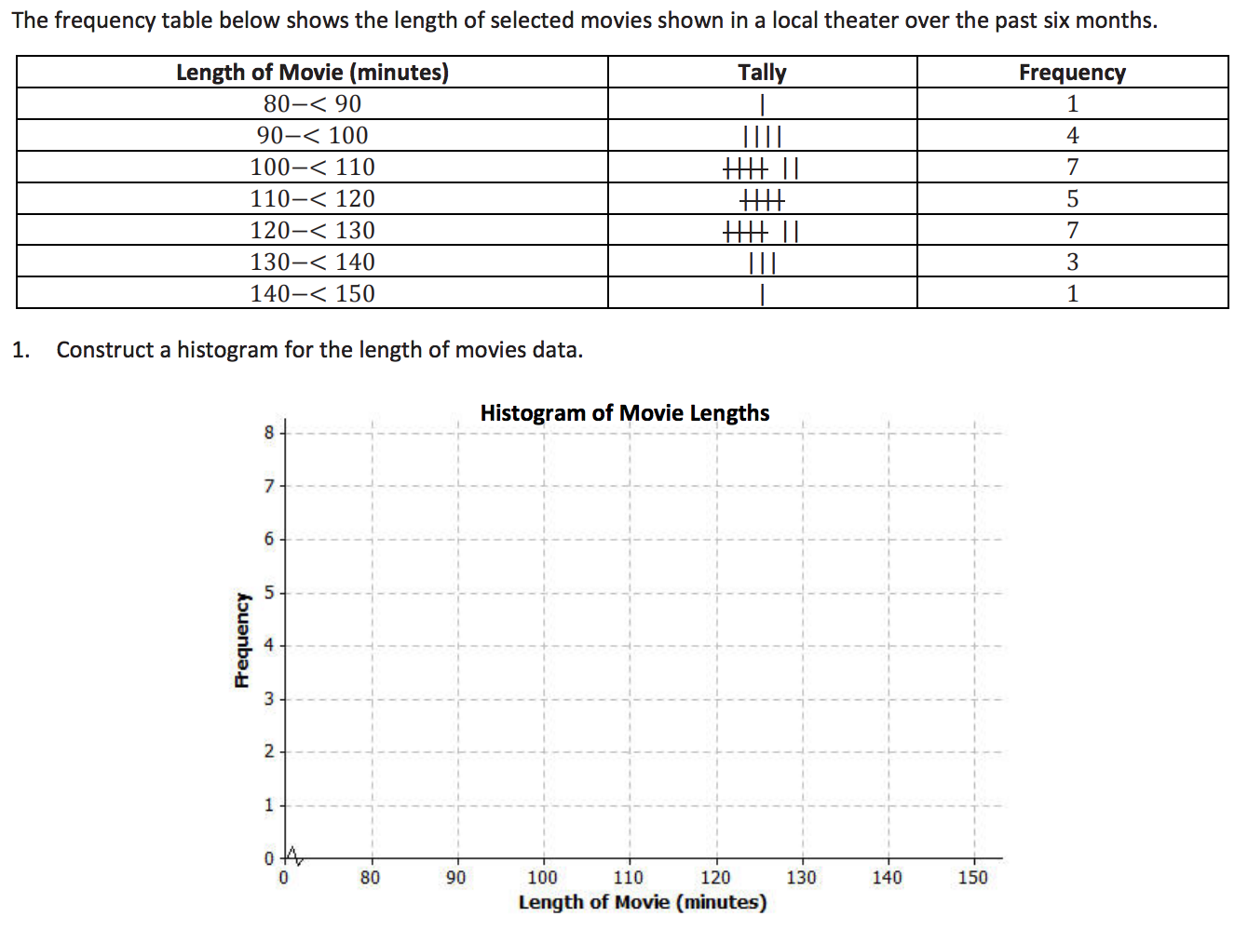

Readiness  - Arrived to class on time  - Actively worked on do now  - Completed do now | Positive Contribution  - Followed along with video notes  - Completed all class notes | Understanding  - Actively worked to complete the practice problems  - Accurately answered the exit ticket
/10 | /30 | /60
Comments:

Grade:____________________

