Name:_______________________________________ Class:________
Directions: Compare the fractions using a common denominator.
(1) ³/₄ ³/₅
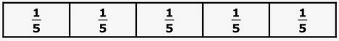
3
4

3
5

(2) ⁵/₈ ¹/₂
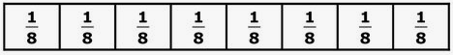
5
8

1
2

(3) ²/₃ ⁷/₁₀
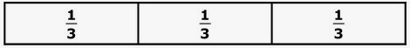
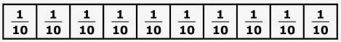
2
3

7
10

(1) -²/₅ -³/₈
2
5

3
8

(2) -³/₁₀ -¹/₂
3
10

1
2
(3) -²/₃ -⁵/₆
2
3

5
6

