Name:_______________________________________________________ Class:______________
Learning Target: I can compare and order fractions.
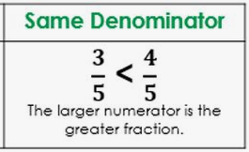
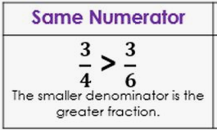

When comparing fractions with unlike denominators you must find a common denominator. Once the denominators match you see which numerator is larger to compare them.

(1) You may find the LCM of the 2 denominators and change the fraction using multiplication.
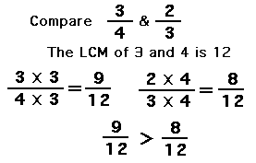
List the multiples of 3 & 4
3: 3, 6, 9, 12, 15, 18, 21, 24, 27, 30
4: 4, 8, 12, 16, 20

OR

(2) You may list equivalent fractions to the given fractions until you find the least common denominator.
3 | 6 | 9 | 12
4 | 8 | 12 | 16

2 | 4 | 6 | 8
3 | 6 | 9 | 12

⁹/₁₂ > ⁸/₁₂ so ³/₄ > ²/₃
Greater

Smaller

How do negative fractions work?

The CLOSER a negative fraction is to 0, the __________________________ the fraction is.

This is opposite of positive fractions.

The F A R T H E R a positive fraction is from 0, the _________________________ it is!

Ex) plot -¹/₂, -³/₅ and -⁷/₁₀ on the number line.

1
2

3
5

7
10

Order them from least to greatest. ___________________________________

