Decimal to Fraction  Step 1 – Look @ Decimal Place Value Chart  Step 2 – Remove decimal and re-write as a fraction  Step 3 – Simplify the Fraction (divide by the GCF of the numerator & denominator)  Ex. .20 becomes $\frac{20}{100}$ because the decimal is in the hundredths place  You need to SIMPLIFY the fraction: divide the top and bottom by the same number until they can not be divided further.  $\frac{20}{100}$ $\frac{÷ 20}{÷ 20}$ = $\frac{1}{5}$ This is the fraction in SIMPLEST form. | PLACE VALUE DECIMAL CHART  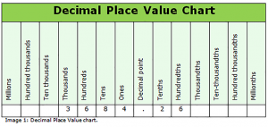
EX.  .405 becomes $\frac{405}{1000}$ because the 5 is in the thousandths place  then SIMPLIFY by dividing repeatedly until it gets to the simplest form.  Divide top and bottom by 5 and you get 81/200…this is the SIMPLEST form | 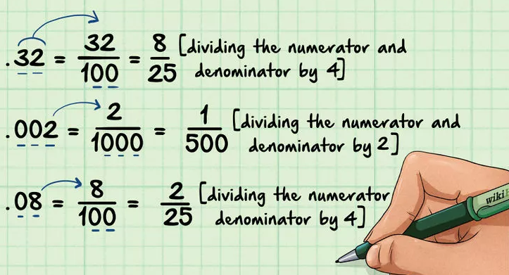

Decimal to Fraction  Step 1 – Look @ Decimal Place Value Chart  Step 2 – Remove decimal and re-write as a fraction  Step 3 – Simplify the Fraction (divide by the GCF of the numerator & denominator)  Ex. .20 becomes $\frac{20}{100}$ because the decimal is in the hundredths place  You need to SIMPLIFY the fraction: divide the top and bottom by the same number until they can not be divided further.  $\frac{20}{100}$ $\frac{÷ 20}{÷ 20}$ = $\frac{1}{5}$ This is the fraction in SIMPLEST form. | PLACE VALUE DECIMAL CHART
EX.

.405 becomes $\frac{405}{1000}$ because the 5 is in the thousandths place

then SIMPLIFY by dividing repeatedly until it gets to the simplest form.

Divide top and bottom by 5 and you get 81/200…this is the SIMPLEST form

