Name:_____________________________________________________________________________________ Class:_____________________
Proving OR Finding Equivalent Ratios using Proportions
Learning Target: I can write and simplify a ratio.

Determining if two ratios are equivalent using a proportion:
(1) Cross multiply: First, multiply the top number of the ratio on the left with the bottom number of the ratio on the right. Then, multiply the bottom number of the ratio on the left with the top number of the ratio on the right.
(2) Determine if the cross products are equal. If they are equal, the ratios are equivalent, if they are not equal, the ratios are not equivalent.

EXAMPLES:
?
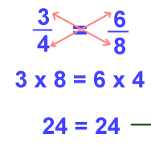
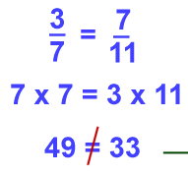
?

Proportional
Not Proportional

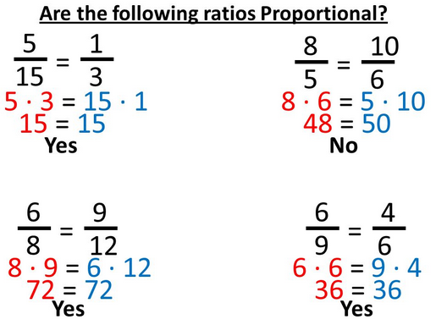
You can also use a proportion to find a missing value from an equivalent ratio. If you are told that two ratios are proportional, you can cross multiply and divide to find a missing value.
You do this by…
(1) Cross multiplying the number from the first ratio that has a partner in the second ratio.
(2) Divide your cross product by the number missing a partner.
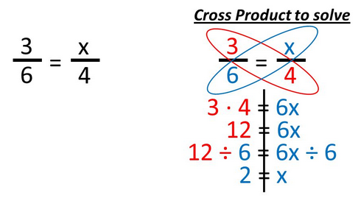
(3) Check your answer.

