Name: ________________________________________________________________ Class: _________________
Complete the table below to represent each expression with an array and in factored form using greatest common factor.

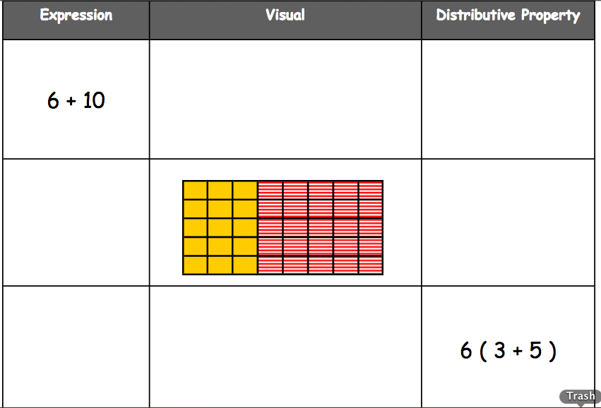
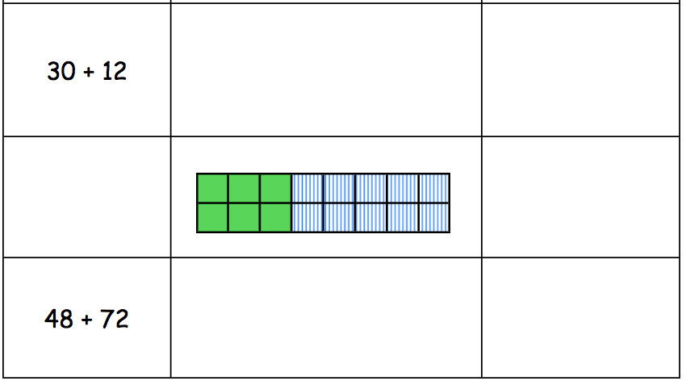

Name: ________________________________________________________________ Class: _________________

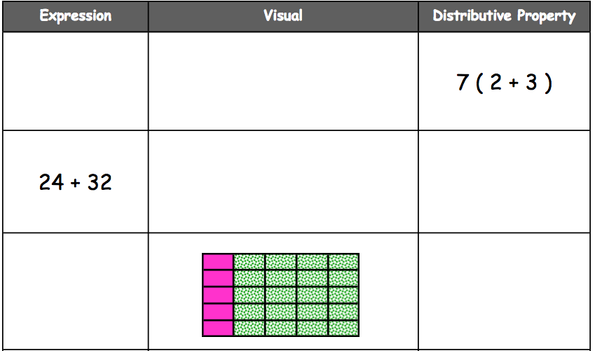
Create a word problem that would require writing an expression in either factored form or expanded form to solve. Be sure to include distractors and an answer key below.

__________________________________________________________________________________________________________________________________________________________________________________________________
__________________________________________________________________________________________________________________________________________________________________________________________________
__________________________________________________________________________________________________________________________________________________________________________________________________
__________________________________________________________________________________________________________________________________________________________________________________________________

