Name______________________________________________________ Date________________ Class___________________
Creating Equivalent Fractions
Directions: Find the missing numbers in the equivalent fractions below.

1.  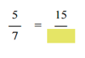  ?=______________________________ | 2.  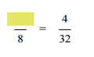  ?=______________________________ | 3.  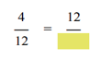  ?=______________________________
4.  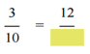  ?=______________________________ | 5.  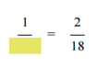  ?=______________________________ | 6.  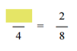  ?=______________________________
7.  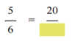  ?=______________________________ | 8.  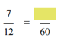  ?=______________________________ | 9.    

