Name______________________ Class_________________________ Date_____________
Finding the GCF- the Rainbow Method

Directions: Find the GCF of the 2 given whole numbers.

1)
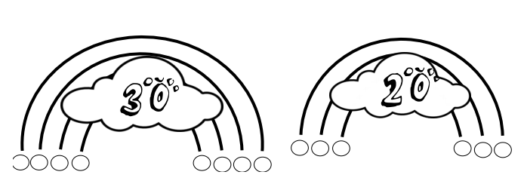
GCF of 30 and 20:______

2)
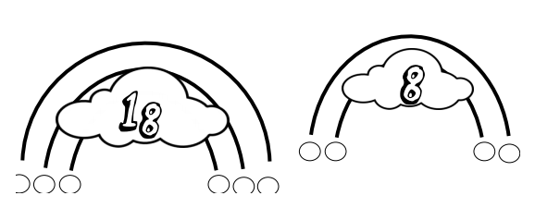
GCF of 18 and 8:_____

3)
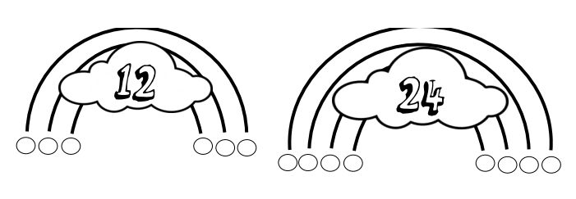
GCF of 12 and 24:_______
4)
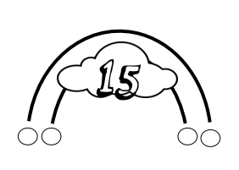
GCF of 10 and 15:______

5)
GCF of 20 and 10:____

6)
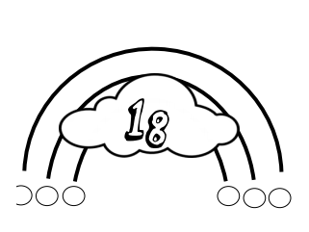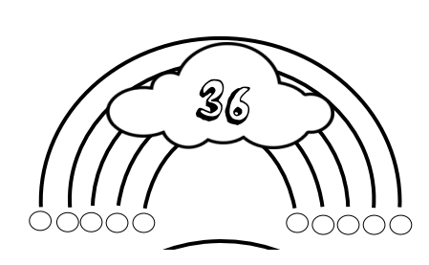
GCF of 18 and 36:_____

