Name:________________________________________ Class:_________ Date:________
Learning Target: I can make predictions about a population.
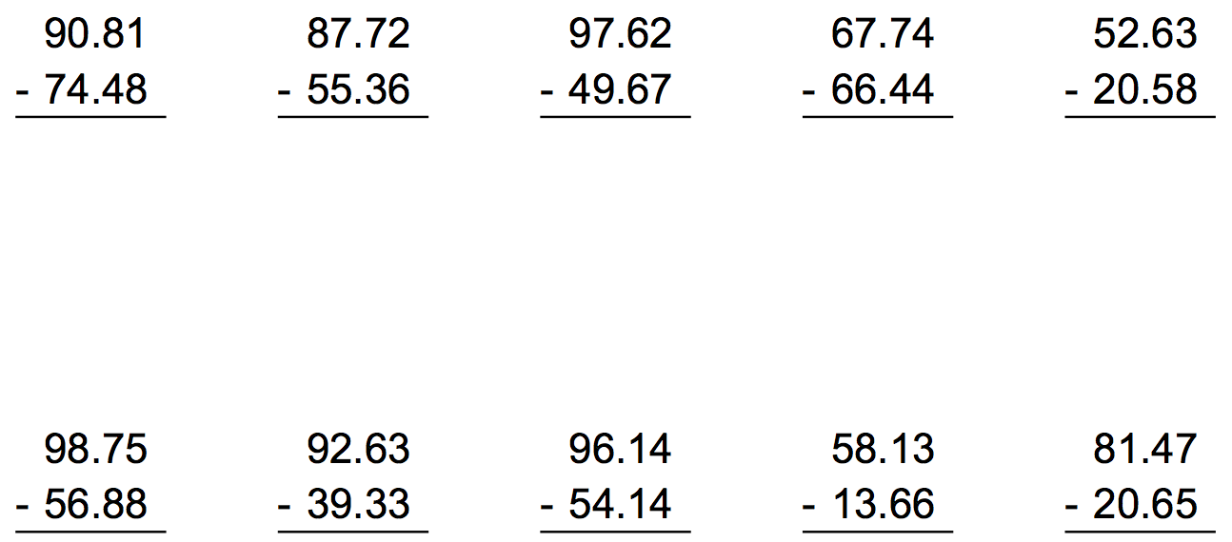

Name:________________________________________ Class:_________ Date:________
Learning Target: I can make predictions about a population.

Name:________________________________________ Class:_________ Date:________
Learning Target: I can make predictions about a population.
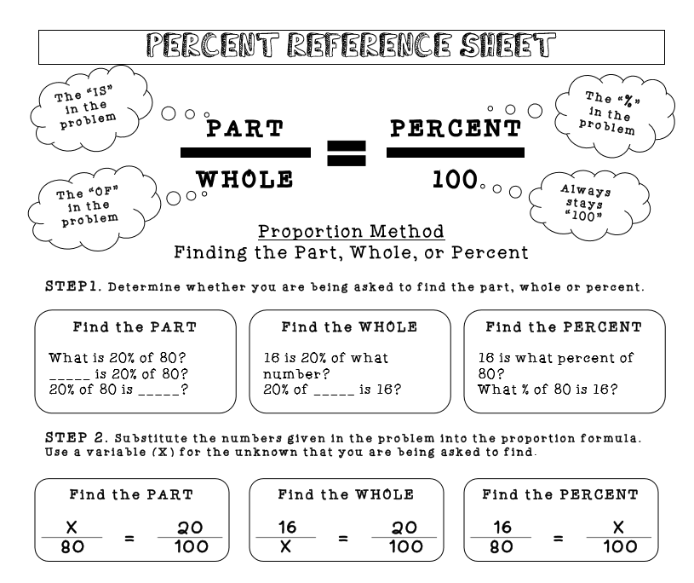

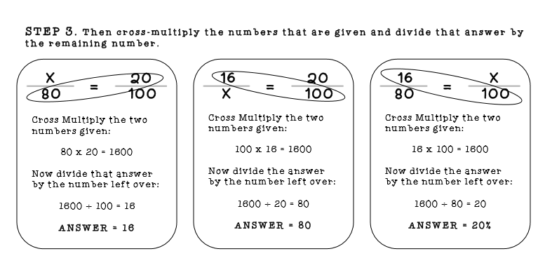

Video notes:

A _______________ is a part of a population.

How many total students are in the school? __________________.

This represents the _____________________

How many students did Anthony survey? ___________________.

This represents the _____________________

What percent of the sample said they would attend the game? ______

Determine how many students will actually attend the game using a percent proportion:

Name:________________________________________ Class:_________ Date:________
Learning Target: I can make predictions about a population.
Readiness  - Arrived to class on time  - Actively worked on the do now | Positive Contribution  - Followed along with video notes  - Filled in all of the notes | Understanding  - Attempted all of the problems during the white board assessments  - Answered the white board assessment questions correctly
/10 | /40 | /50
Comments:

Grade:___________

Name:________________________________________ Class:_________ Date:________
Learning Target: I can make predictions about a population.
Readiness  - Arrived to class on time  - Actively worked on the do now | Positive Contribution  - Followed along with video notes  - Filled in all of the notes | Understanding  - Attempted all of the problems during the white board assessments  - Answered the white board assessment questions correctly
/10 | /40 | /50
Comments:

Grade:___________

