Name______________________________ Date______________ Class_________
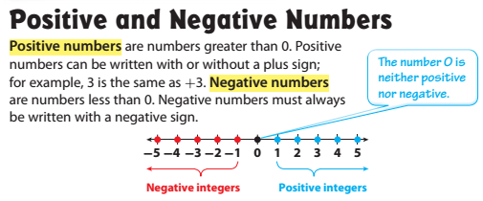
Model:

1. Part A:
Graph and label the following points on the number line.

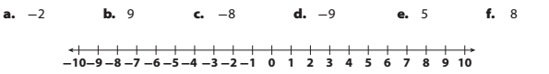
Part B:
Order the integers from least to greatest:
___________________________________________
2.
