Name_______________________________ Date___________ Class__________A
Ordering Negative and Positive Integers
Independent

1. Part A: Graph the integers on the number line.
4, -6, 0, 8, -9, 1, -3

Part B: Order the integers from least to greatest.

_________________________________________________________________
2. Part A: Graph the integers on the number line.
-6, 4, 7, -10, 5, 2, -7

Part B: Order the integers from least to greatest.

_________________________________________________________________
- Graph the temperature for each city on the number line.

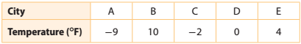

Part A: Graph the integers on the number line.

Part B: Order the integers from least to greatest.

_________________________________________________________________

Part C: Answer the following questions based on the temperature

Which city was coldest?__________________ Which city was warmest?____________

4. Graph the temperature for each city on the number line.

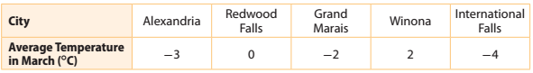
Part A: Graph the integers on the number line.
Part B: Order the integers from least to greatest.

_________________________________________________________________

Part C: Answer the following questions based on the temperature

Which city was coldest?__________________ Which city was warmest?____________

- A hockey league tracks the plus-minus records for each player. A plus-minus record is the difference in even strength goals for and against the team when a player is on the ice. The following table lists the plus-minus values for several hockey players.
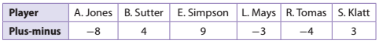
Part A: Graph the integers on the number line.
Part B: Order the integers from least to greatest.

_________________________________________________________________
- For a stock market project, five students each invested pretend money in one stock. They tracked gains and losses in the value of that stock for one week. In the following table, a gain is represented by a positive number and a loss is represented by a negative number.
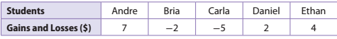
Part A: Graph the integers on the number line.
Part B: Order the integers from least to greatest.

_________________________________________________________________

Name_______________________________ Date___________ Class__________B
Ordering Negative and Positive Integers
Independent
- Graph the temperature for each city on the number line.

Part A: Graph the integers on the number line.

Part B: Order the integers from least to greatest.

_________________________________________________________________

Part C: Answer the following questions based on the temperature

Which city was coldest?__________________ Which city was warmest?____________

2. Graph the temperature for each city on the number line.

Part A: Graph the integers on the number line.

Part B: Order the integers from least to greatest.

_________________________________________________________________

Part C: Answer the following questions based on the temperature

Which city was coldest?__________________ Which city was warmest?____________

- A hockey league tracks the plus-minus records for each player. A plus-minus record is the difference in even strength goals for and against the team when a player is on the ice. The following table lists the plus-minus values for several hockey players.
Part A: Graph the integers on the number line.

Part B: Order the integers from least to greatest.

_________________________________________________________________
- For a stock market project, five students each invested pretend money in one stock. They tracked gains and losses in the value of that stock for one week. In the following table, a gain is represented by a positive number and a loss is represented by a negative number.
Part A: Graph the integers on the number line.

Part B: Order the integers from least to greatest.

_________________________________________________________________
- The table lists the lowest elevation for several countries. A negative number means the elevation is below sea level, and a positive number means the elevation is above sea level. Compare the lowest elevation for each pair of countries. **Hint: use the signs < or >.
A. Argentina and the United States___________

B. Czech Republic and Hungary ______________

C. Hungary and Argentina__________________

D. Which country in the table has the lowest elevation?____________________________

