Name: _____________________________________________ Class:__________ Date: _________

**Learning Target**: I can write and simplify a ratio.

**Ratios**

1. Ms. Kabinoff has 6 scallops and 3 sea stars in his aquarium.

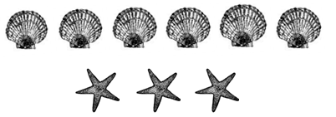

1. What is the ratio of sea stars to scallops? _____________
2. Ms. Kabinoff wants to add scallops and sea stars to her aquarium. She wants the ratio to remain the same. If she now has 12 sea stars, how many scallops should she have?

**Show your work:**

Answer:___________________

1. Ms. Scuderi also has an aquarium. She has 15 scallops and 21 sea stars. What is the ratio of sea stars to scallops in Ms. Scuderi’s aquarium?

**Show your work:**

Answer:___________________

1. Dominique has 12 playing cards. She places 2 cards face- up out of every 3 cards put down on the table.

= face-up = face-down

1. Draw Dominique’s cards, showing how many cards are face-up and how many are face-down.
2. If Dominique continues this pattern with 36 cards, how many cards will be face up?

**Show your work:**

Answer:___________________

1. Using her 12 playing cards, Dominique wants to change the ratio to be 3 cards to be face down out of every 4 cards on the table. Draw what Dominique’s 12 cards look like now.