Teachers:
- Students should be broken into pairs (1 v. 1) or groups of 4 (2 v. 2) to play the game
- You must cut out of the cards (you may want to create more or different cards than what is given
- You must have counters for students to cover the game board (similar to Bingo)
- When a student or team selects a card, they must then cover a shape on the board that represents that ratio
- You win by getting 4 in a row in any direction (horizontal, vertical, diagonal)
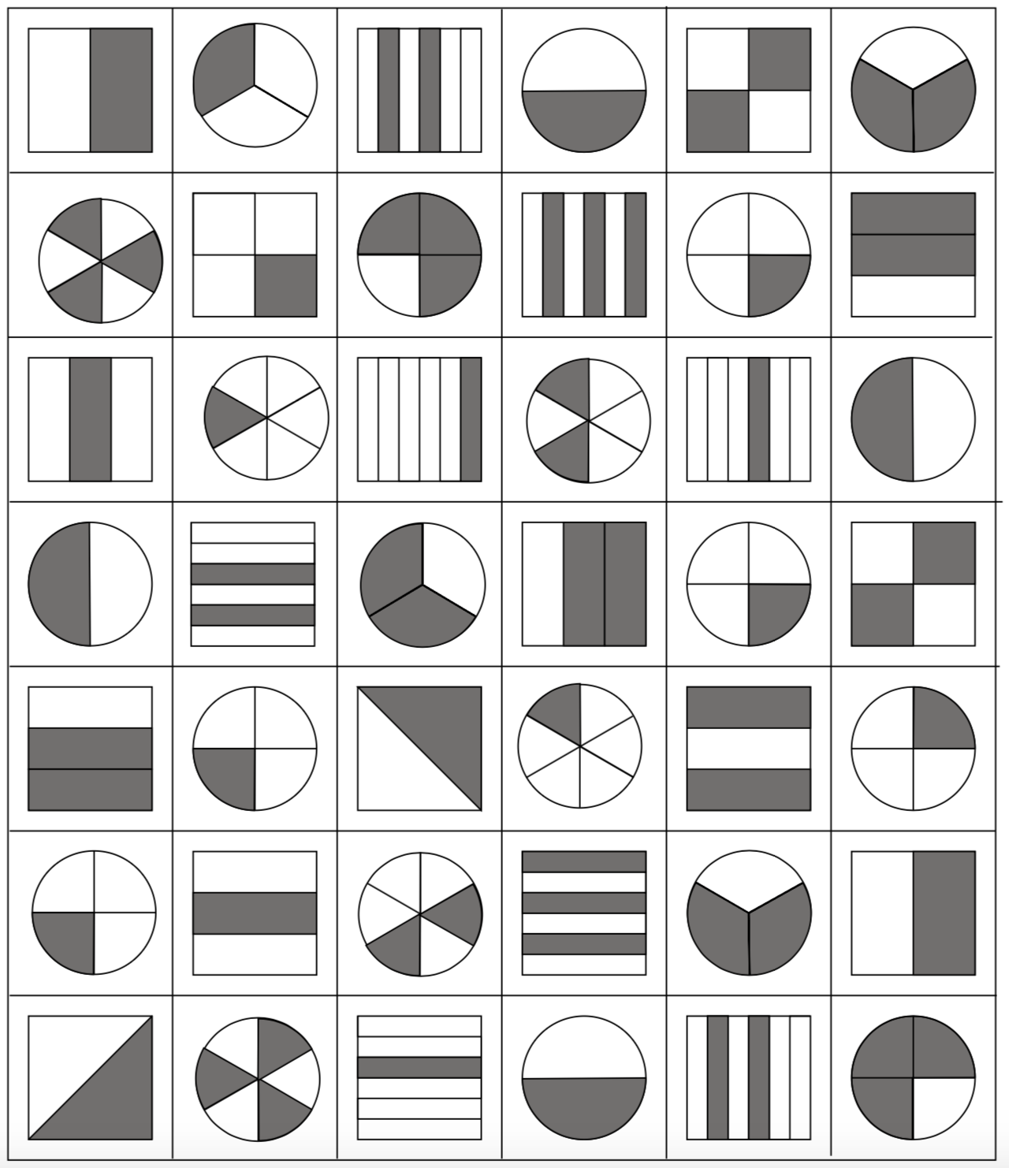
Ratio Rows
