Name:______________________________________________ Class:_______

Learning Target: I can write and simplify the ratios.

----------------------------------------------------------------------------------------------

A ***ratio*** is an ordered pair of numbers, denoted as either *a* : *b*, *a* to *b* or  and read as a comparison of *a* to *b*.

----------------------------------------------------------------------------------------------

The three ways to write a ratio is:

1. Using a colon :
2. Using the word “to”
3. Using a fraction line

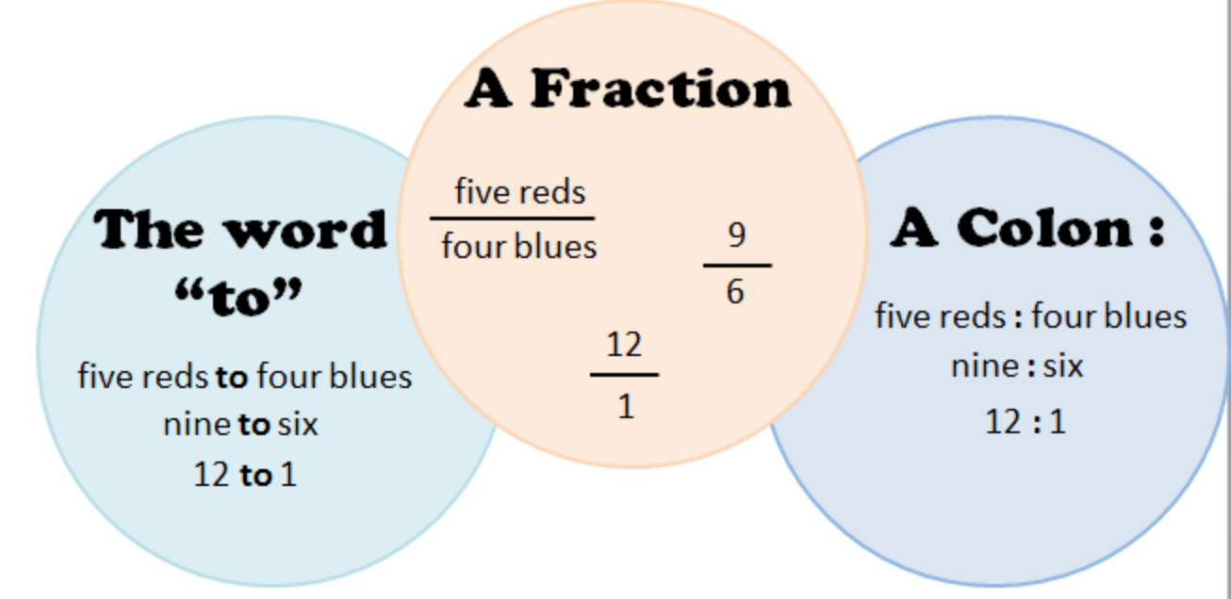

----------------------------------------------------------------------------------------------

Generally, ratios relate values in one of three types: *part-to-part, part-to-whole,* or *whole-to-part.* *a* to *b* represent the parts in the situation. *a* + *b* = *c*, and c represents the total in the situation.

part-to-part *a* : *b* or *b* : *a* In the other notation,  or .

part-to-whole *a* : *c* or *b* : *c* In the other notation,  or .

whole-to-part *c* : *a* or *c* : *b* In the other notation,  or .

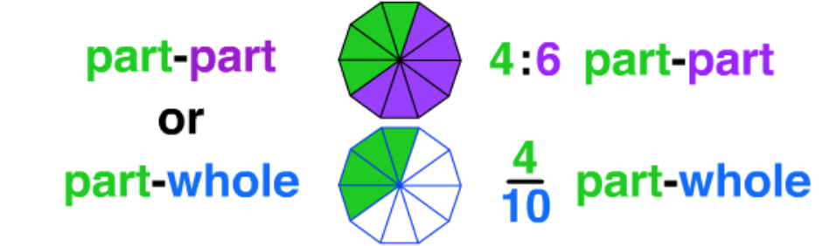

Examples.

1. In a school with 420 students and 35 teachers:

(a) What is the ratio of students to teachers? _______________________

(b) What is the ratio of teachers to students? _______________________

(c) Which type of a ratio did you use for each of the above? _____________________

2. A school had 180 boys and 240 girls attending.

(a) What is the ratio of boys to girls? _______________________

(b) What is the ratio of girls to boys? _______________________

(c) Which type of ratio was used for a & b? _______________________

(d) What is the ratio of students to boys? _______________________

(e) Which type of ratio was used for d? _______________________

(f) What is the ratio of girls to students? _______________________

(g) Which type of ratio was used for f? _______________________

3. A recipe calls for 2 parts sugar, 5 parts flour, and 3 parts milk.

(a) What is the ratio of sugar to flour to milk? _______________________

(b) What is the ratio of sugar to the whole recipe? _______________________